**Course-CS691**

**Assignment 2 & 3 Report: Exploring AI Algorithms in Deep Learning**

**Name:** Tharun Chowdary Malepati **Email:** tmalepati@crimson.ua.edu

**Overview of the assignment:**

This report is part of the CS-691 Assignment where I looked at two different ways to create images using Deep Generative Models. These are called Variational Autoencoders (VAEs) and Generative Adversarial Networks (GANs). I used them to Generate images from two datasets, which are collections of images, called MNIST and CIFAR-10. MNIST has pictures of handwritten digits, and CIFAR-10 has pictures of everyday objects like airplanes and cars.

In the report, I will talk about what VAEs and GANs are and how they work. I will also show the images they created and discuss which way worked better and why. Finally, I will talk about some of the challenges I faced when doing this project.

**Variational Autoencoders (VAEs):**

1. **Variational Autoencoders using MNIST Dataset:**

**Working of Encoder Network**:

It is used to compress input images into a smaller, dense representation which we call the latent space.

**Input**: Handwritten digit images from the MNIST dataset.

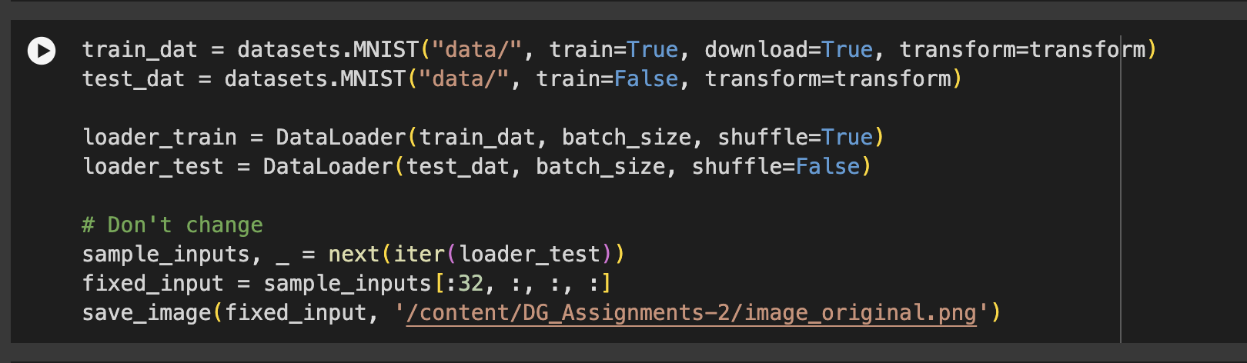

**Components**:

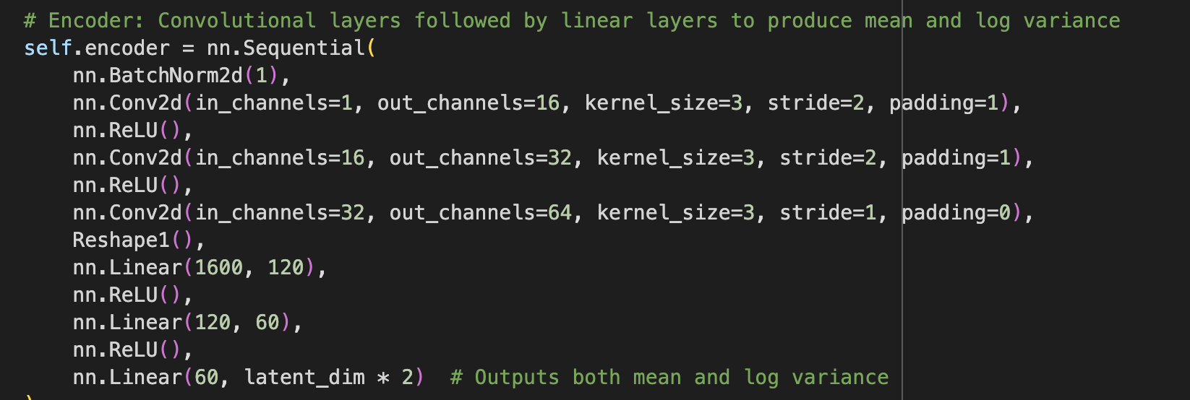

* **Convolutional Layers**: These layers apply filters to the input images to capture spatial hierarchies of features. They help in recognizing patterns like edges, textures, and more complex shapes within the digits.
* **Activation Functions**: Non-linear functions like ReLU (Rectified Linear Unit) introduce non-linear properties to the model, allowing it to learn more complex patterns.
* **Pooling Layers**: These layers reduce the dimensionality of the data by combining the outputs of neuron clusters at one layer into a single neuron in the next layer.
* **Dense Layers**: Fully connected layers that further compress the information into a dense representation.

**Output**: Two sets of vectors, one representing the means (μ) and the other log variances (log*σ*2) of the latent space distributions for each input image.

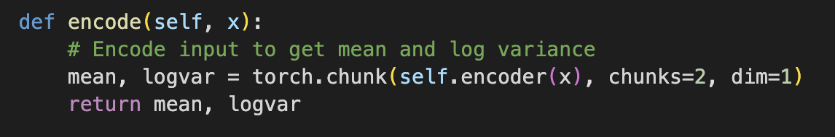

**Working of Latent Space**:

**Purpose**: To capture the essential information of each input image in a more compact form.

**Components**:

* **Z Sampling**: Using the means and log variances from the encoder, it samples a point from the latent space distribution, introducing randomness and variability into the model, which is essential for generating diverse outputs.

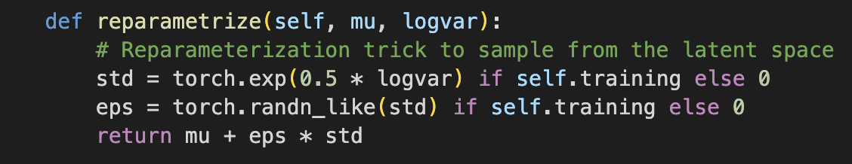

**Working of** **Decoder Network**:

**Purpose**: To reconstruct the input images from their latent space representations, essentially reversing the encoding process.

**Input**: Sampled points from the latent space.



**Components**:

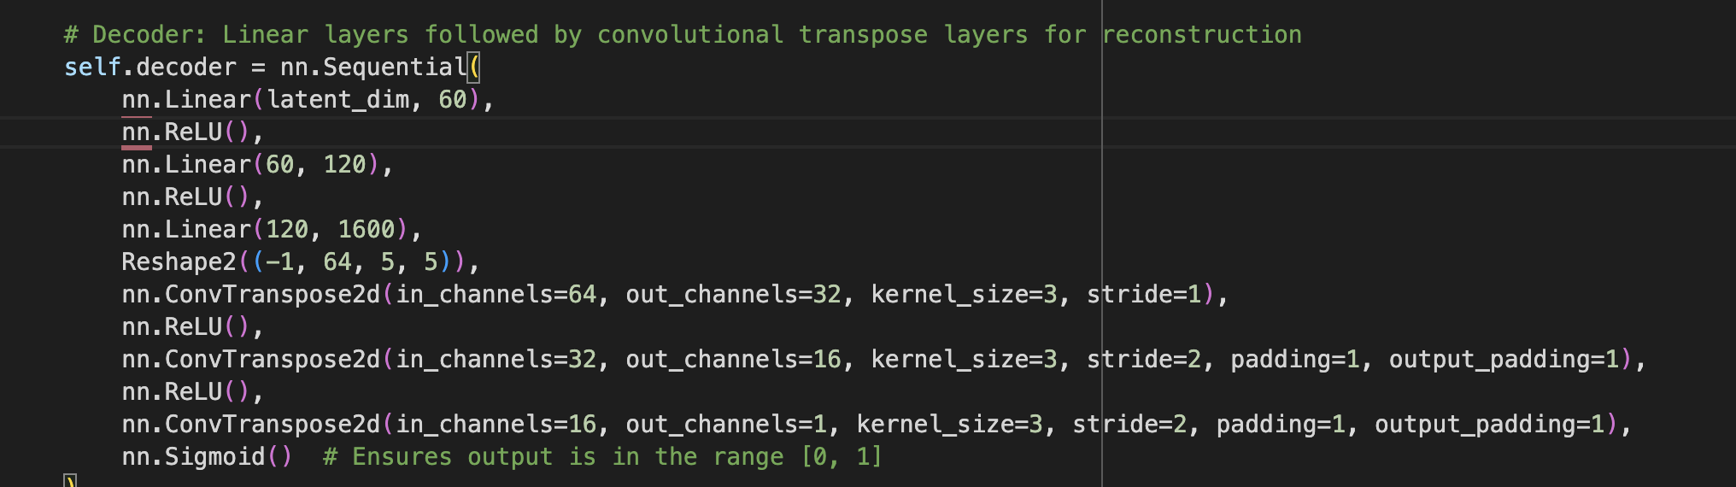

* **Dense Layers**: Initially expand the compact latent representation back into a more detailed form.
* **Activation Functions**: Introduce non-linearity to enable complex pattern generation.
* **Convolutional Layers (transposed convolution)**: These layers perform the opposite of convolutional layers, upscaling the data instead of downscaling, and reconstructing the detailed features of the original input images.
* **sigmoid function**: It is also known as the logistic function, which is a mathematical function that converts any real-valued number into a value between 0 and 1. It's widely used in various fields, including statistics, computer science, and especially in neural networks for binary classification problems.

**Output**: Reconstructed images, which are compared against the original input images to determine how well the VAE has learned to encode and decode the digits.

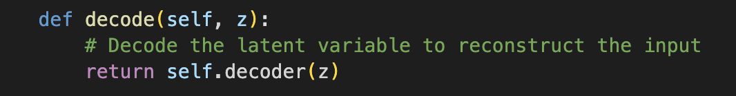

**4) Loss Function:**

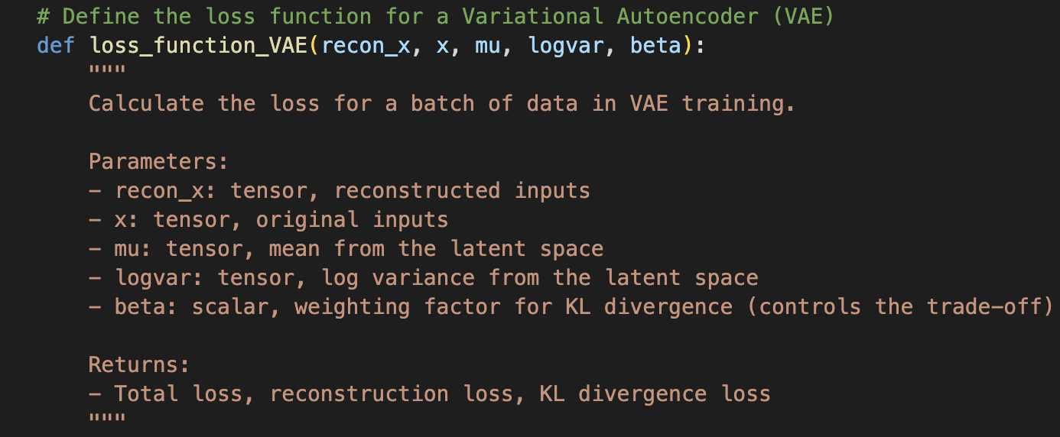

**Components**:

* **Reconstruction Loss**: Measures how well the reconstructed images match the original inputs, encouraging the decoder to produce accurate reconstructions.



* **KL Divergence**: Measures how much the learned latent distribution diverges from a standard normal distribution, encouraging the encoder to produce distributions that closely resemble a normal distribution.

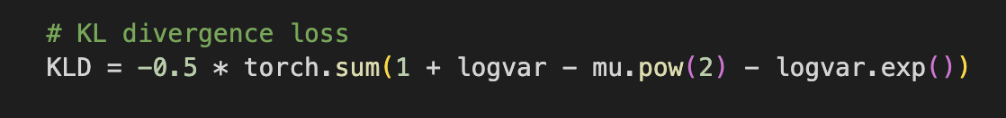

* **Output**:



**Implementation and Hyperparameters used:**

* + Framework used PyTorch.

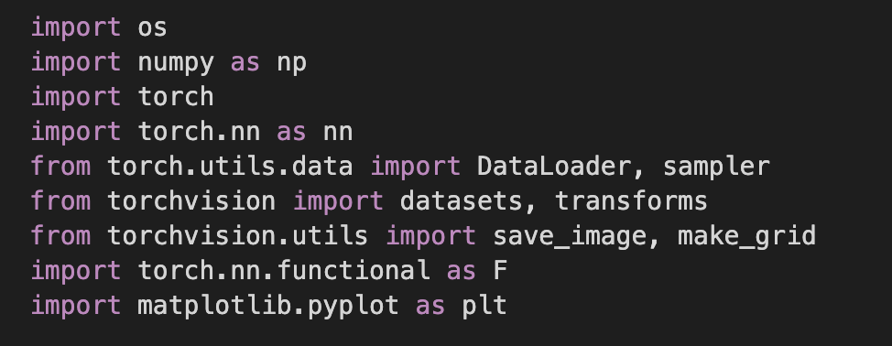

* + Key hyperparameters:

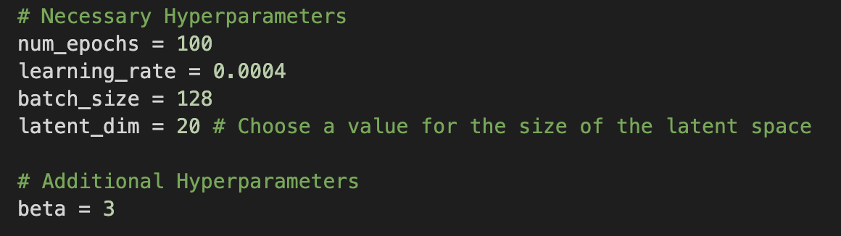

* **Number of Epochs (num_epochs)**: The number of complete passes through the entire dataset.
* **Learning Rate (learning rate)**: This controls how much the model's weights should be adjusted concerning the loss gradient.
* **Batch Size (batch size)**: The number of samples that will be propagated through the network at one time. It is an important factor that affects the model's generalization and speed of convergence.
* **Latent Dimension (latent dim)**: The size of the latent space vector. This hyperparameter sets the complexity of the encoded representation of the input data. The method of determining its value is not given in the provided excerpt.
* **Beta (beta)**: A weighting factor for the Kullback-Leibler divergence term in the loss function. It controls the trade-off between the reconstruction loss and the KL divergence, affecting how the latent space is organized.
  + Issues with convergence, image quality, latent space interpretation, etc.
  + Strategies you used to address these.
* **Challenges Faced:**
  + **Image Quality**: The reconstructed images are blurry or lack detail compared to the original MNIST digits. We can see this in the below figure.

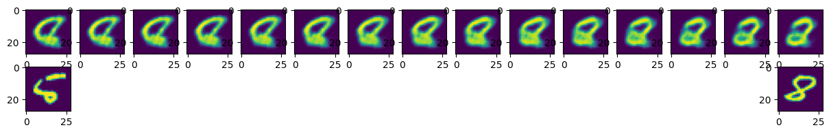

* + **Mode Collapse**: In some cases, the VAE might generate very similar outputs for different inputs, a problem known as mode collapse, where the diversity of the output is significantly less than expected. We can see above as an example of how 8 looks like 5.
  + **Computational Resources**: Training deep learning models is resource-intensive, and I have encountered limitations in terms of available computational memory for Google Collab Pro, which can restrict the size of the model or the speed of training.
  + **Overfitting**: The model might perform well on the training data but poorly on unseen test data, indicating that it has not generalized well but rather memorized the training examples.
* **Results:**
  + Interpolate from 0 to 9:

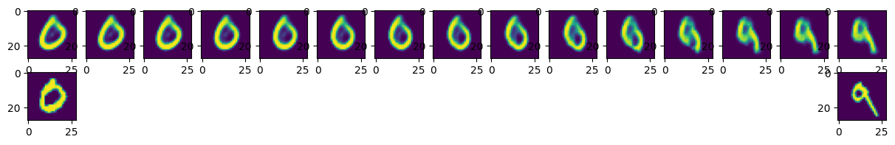

* + Interpolate from 4 to 9:

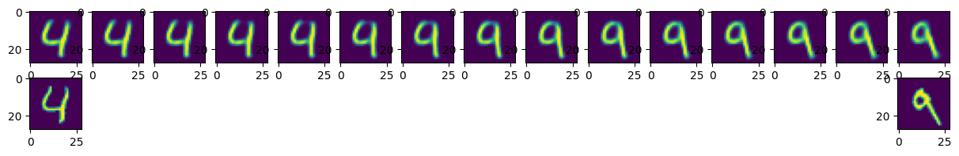

* + Interpolate from 1 to 2:

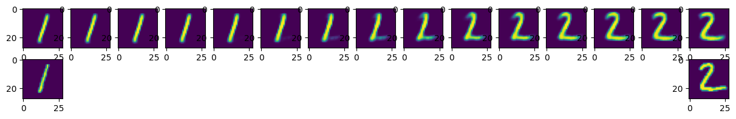

* + Plotting for Train loss and Test loss with respective 10 epochs.

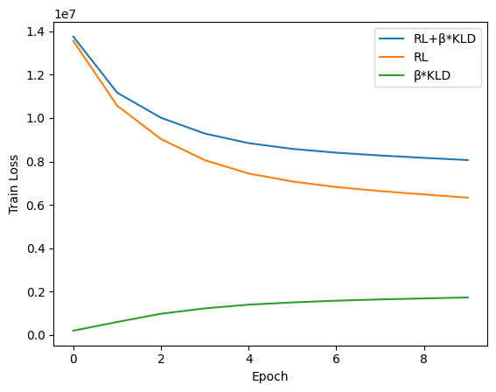

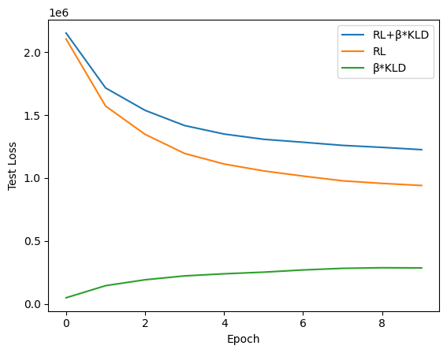

* + Plotting for Train loss and Test loss with respective 100 epochs.

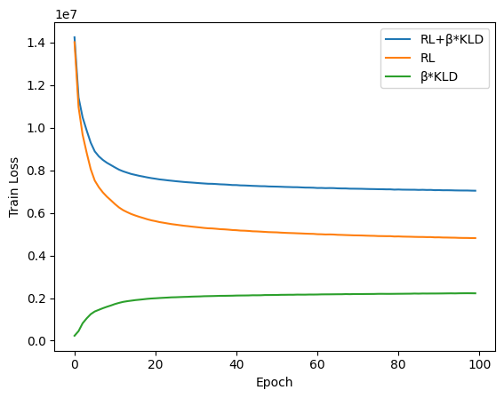

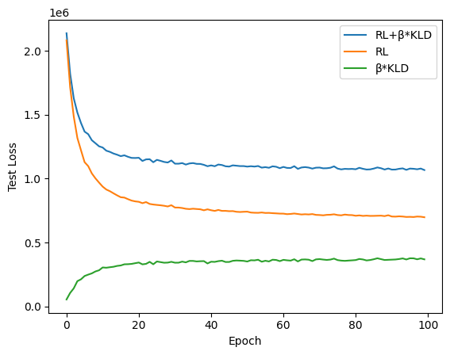

* **Latent Space Visualization via t-SNE**:

We used a special technique called t-SNE to create a map that shows how the computer understands different handwritten numbers. Imagine drawing dots on a piece of paper where each dot is one of the numbers from 0 to 9. We colored each dot based on the number it represents. When we finish, dots with the same color (the same number) should end up close together if the computer is doing a good job. When we looked at our map, we could see groups of colors that told us our computer was able to tell the numbers apart well, which is exactly what we wanted it to do.

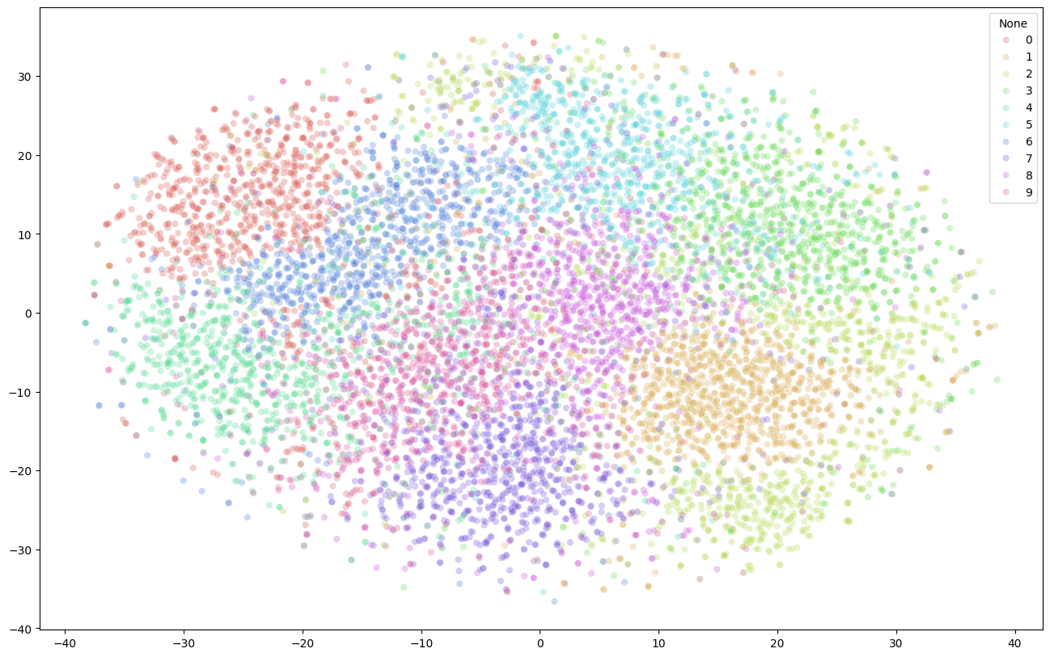

* **Interactive Visualization of MNIST dataset:**

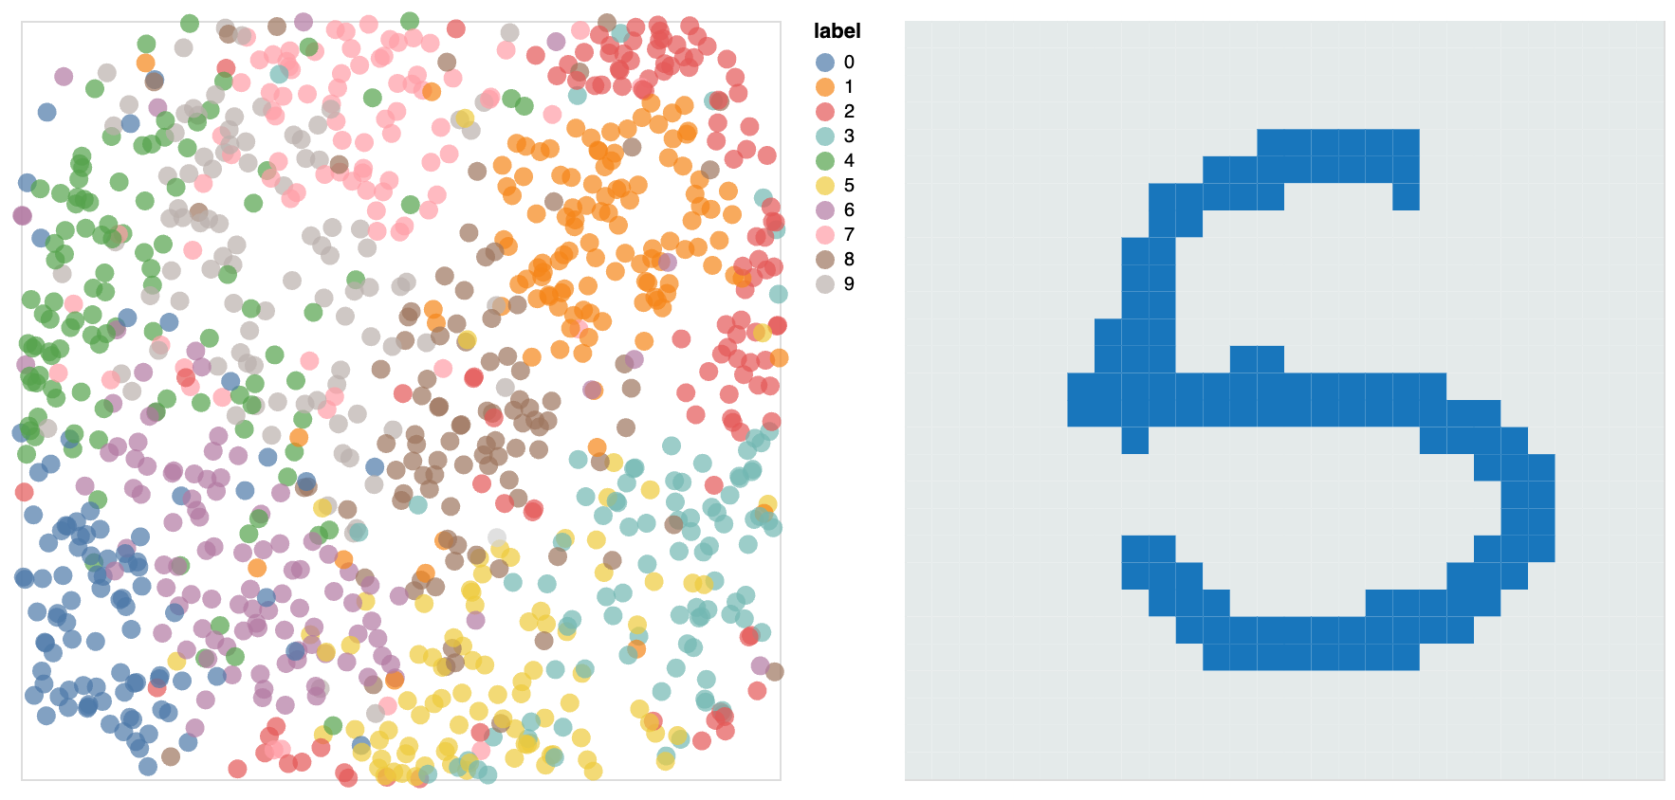

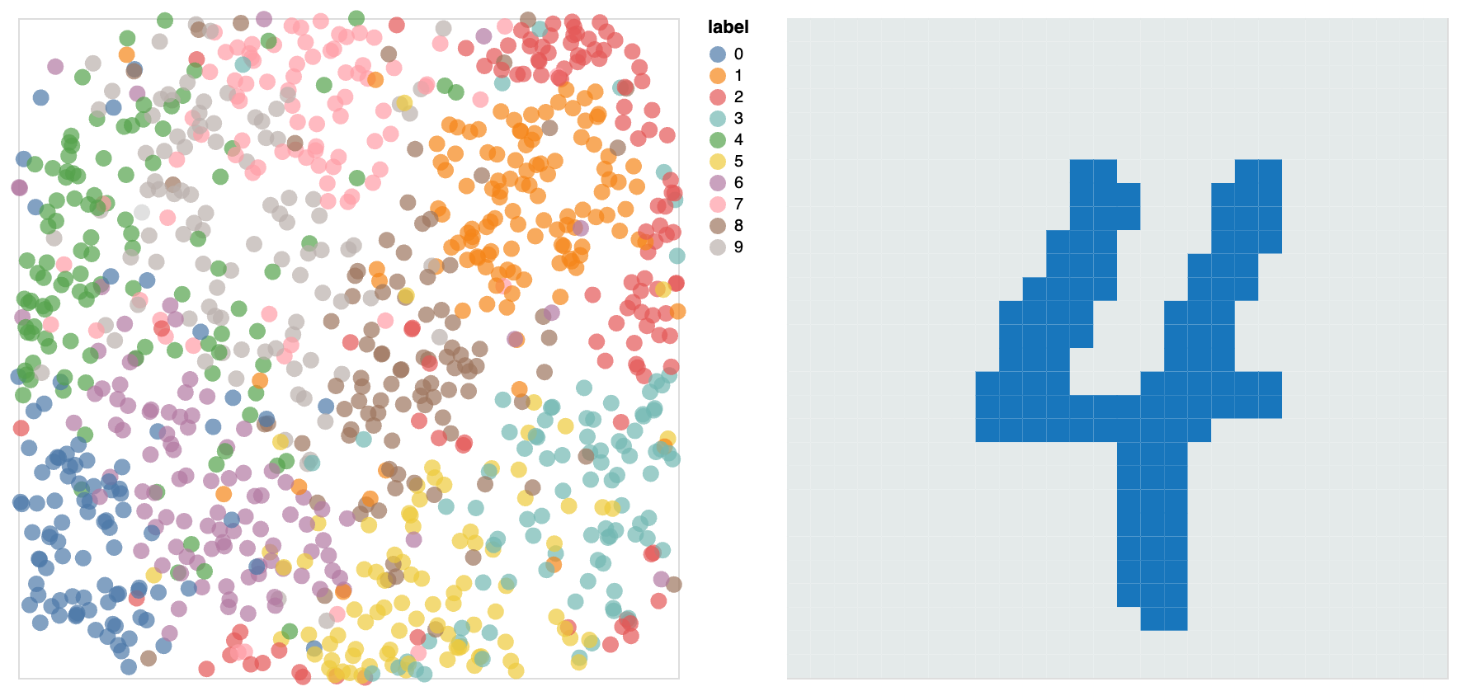

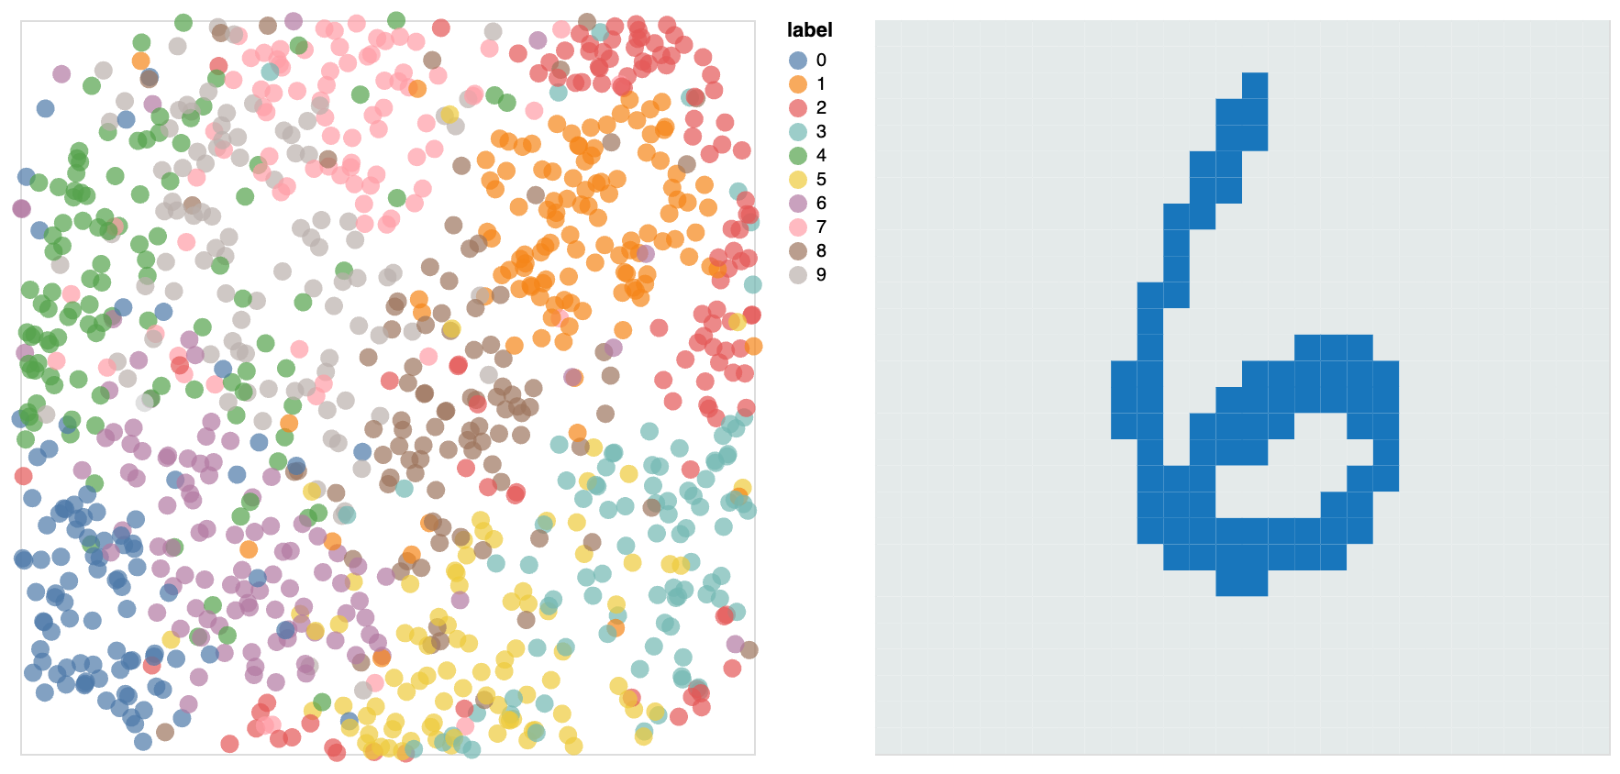

1. **Variational Autoencoders using CIFAR-10 Dataset:**

**Data preparation:**

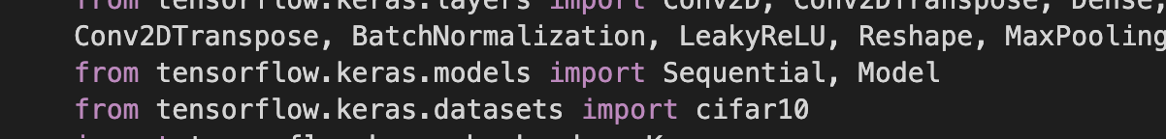

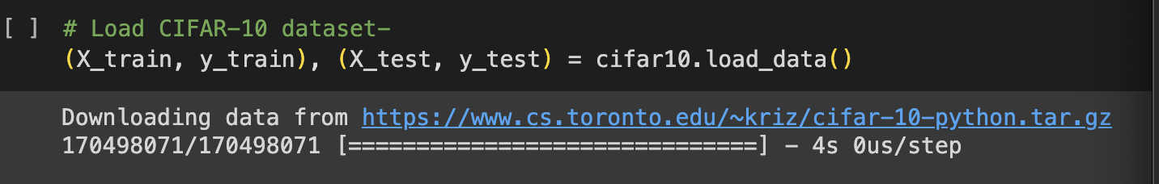

**Working of Encoder Network and Latent Representation:**

Conv6_Encoder is an encoder network that tells a computer how to take a big, complex image and turn it into a simpler, smaller code that still holds the essence of the original image. Imagine we have a detailed drawing, and you want to create a simple sketch that captures its main features without all the details. That's kind of what this encoder does with digital images.

This Network starts with a specific task: images that are 32 by 32 pixels big and have colors (the "3" stands for the red, green, and blue color channels). Think of each image as a tiny square filled with tiny colored dots.

**Three Special Filters**: The encoder uses three sets of filters (think of them as unique glasses) to look at the image. Each set of glasses helps the computer focus on different parts of the image, from the obvious to the not-so-obvious details. After looking through each set:

* The first makes the image smaller, focusing on the big stuff.
* The second shrinks it again, capturing intermediate details.
* The third one reduces it further while trying to keep the tiny, crucial details.

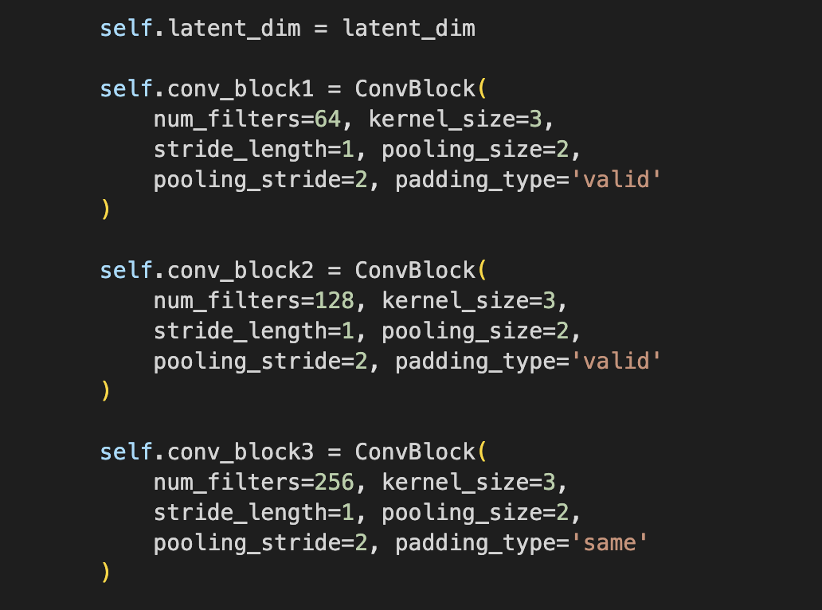

**Flattening**: After the image has gone through all three filters, it's transformed into a long string of numbers. This step is like taking the 3D model of a building and turning it into a flat blueprint. It's simpler and easier to work with but still describes the building.

**Simplifying Further**: The long string of numbers then goes through a special process that distills it down to even fewer numbers. This final step is like summarizing a long story into a single sentence that captures its essence.

**Dense layer**: uses a dense layer, a kind of neural network layer, to press this long line of numbers into an even shorter, more abstract representation. This step is crucial because it's where the encoder focuses on the essence of the image.

**Batch Normalization**: To ensure that this abstract representation is as clean and as stable as possible, the encoder uses a technique called batch normalization. This step adjusts the numbers so that they're easier for the model to work with, like tuning a musical instrument before a performance.

**Activation**: The last touch involves a little bit of fine-tuning to make sure the summary (the simple code) is as good as it can be. It's a bit like adjusting the contrast on a photo to make it clearer.

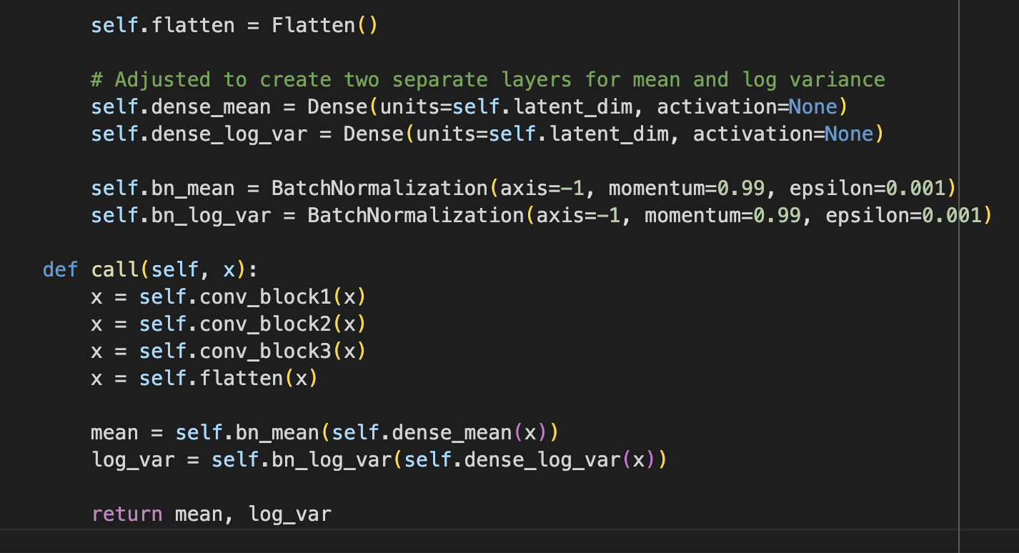

In the end, what started as a detailed, colorful image becomes a much simpler code. This code doesn't look like the image at all to us, but to the computer, it contains all the essential information needed to understand what the image is about or to reconstruct a version of the original image later.

This encoder is smart because it figures out on its own what parts of the image are important and what can be ignored, making it very efficient at turning complex images into simple codes.

**Checking GPU Availability:**

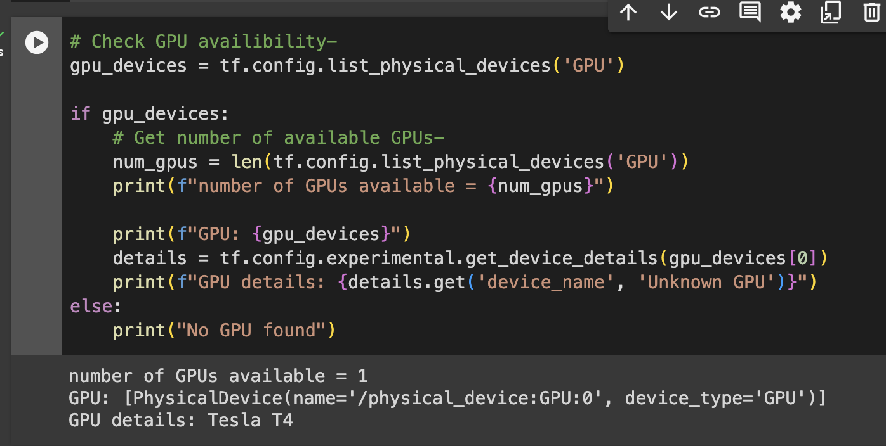

I have used a Tesla T4 GPU.

**Working for Decoder Network:**

The Conv6_Decoder class is a sophisticated neural network model designed to reconstruct images from a compact, encoded representation known as the latent space. It is an essential component of a Convolutional Variational Autoencoder (VAE), tasked with the inverse operation of the encoder. The decoder works by gradually upscaling and refining this compressed information back into a high-resolution image.

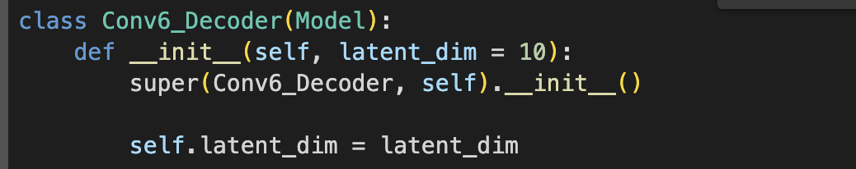

**Initial Dense Layers**

The journey from encoded data back to an image begins with the decoder's initial dense layers. These layers perform the first step in reversing the encoding process:

* **Dense Layer 1 (dense0)**: Starts the process by taking the latent representation and transforming it through a fully connected layer. This step begins to map the encoded data back towards the higher-dimensional space of images.
* **Batch Normalization (bn0)**: Following the dense layer, batch normalization is applied to stabilize and standardize the activations, improving the training process and helping the network to generalize better.

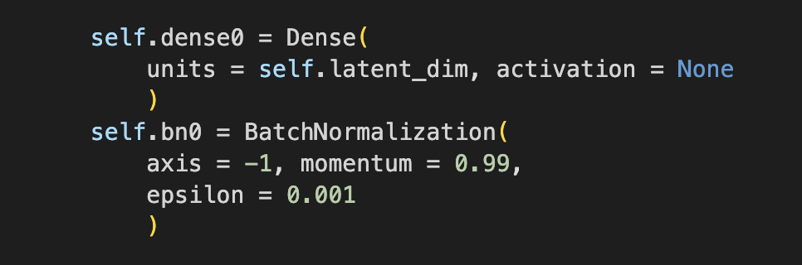

After the initial transformation, the decoder continues to expand the data through additional dense layers, preparing it for reshaping into a format suitable for convolutional processing:

* **Dense Layers 2 and 3 (dense, dense2)**: These layers progressively increase the dimensionality of the data, preparing it for the spatial structure of image data. Each dense layer is followed by batch normalization (**bn**, **bn2**), ensuring the data remains normalized and conducive to effective learning.

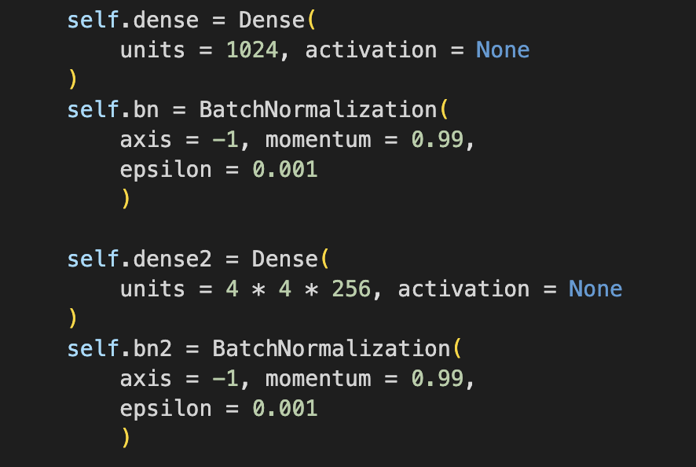

The decoder then reshapes the expanded, linear data into a multi-dimensional format, setting the stage for the convolutional transpose operations:

* **Reshaping (reshape)**: The data is reshaped into a 4x4 grid with 256 channels, mirroring the process of convolution but in reverse. This step transitions the model from processing linear data to handling spatial, image-like data.
* **Convolutional Transpose Layers**: A series of convolutional transpose layers (**conv_transpose_layer1** to **conv_transpose_layer6**) then incrementally upscale the data. These layers effectively reverse the convolution operation, increasing the resolution and adding back details at each step. Batch normalization follows each convolutional transpose layer, further refining the output.

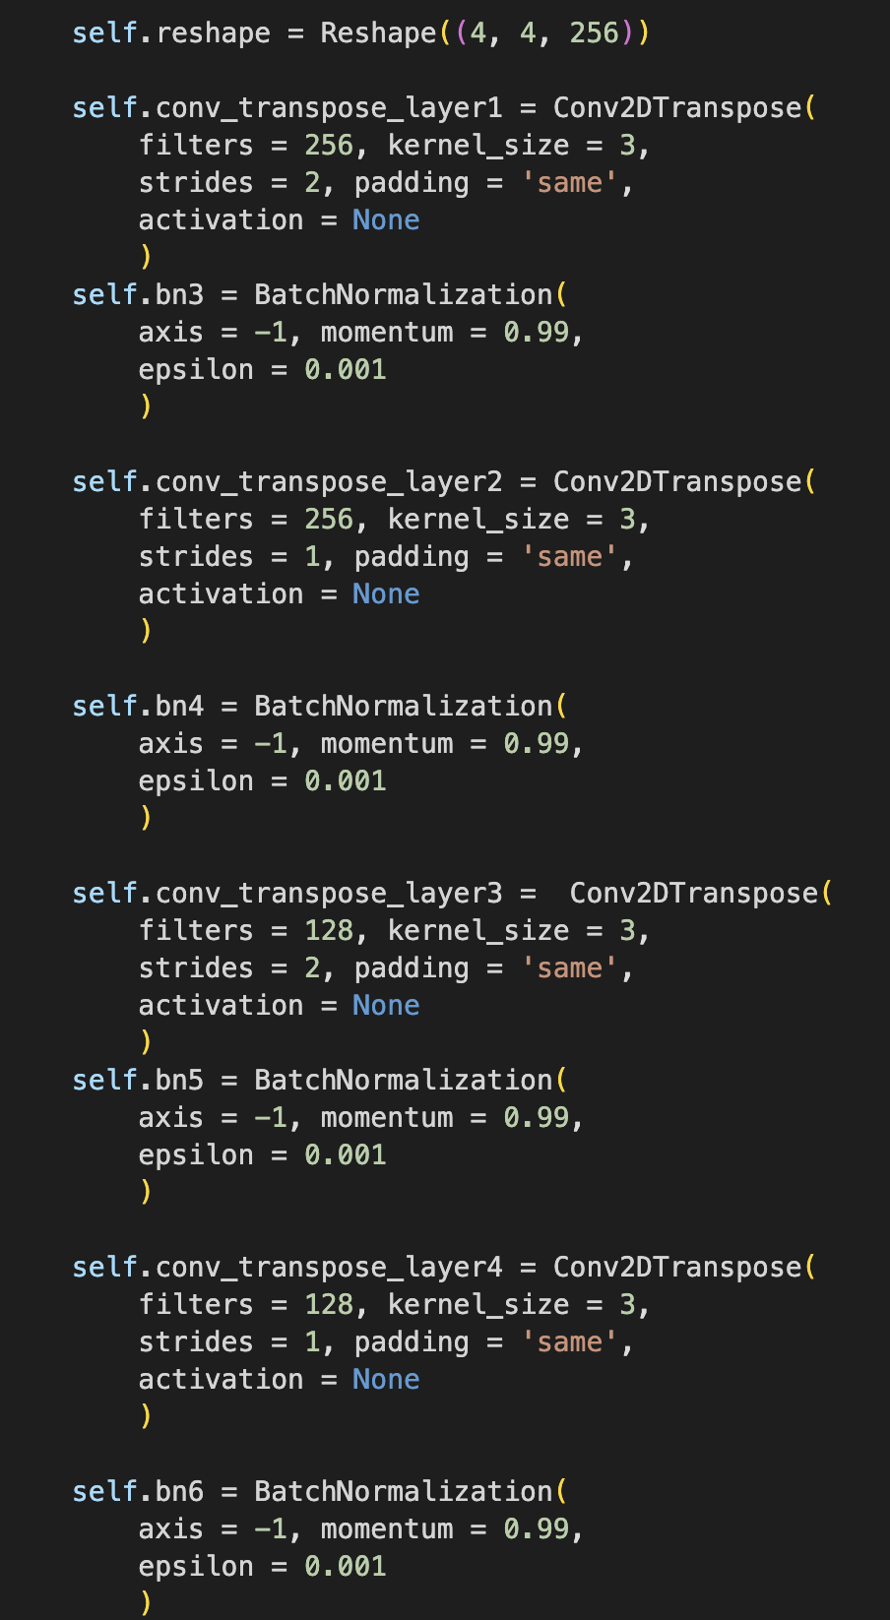

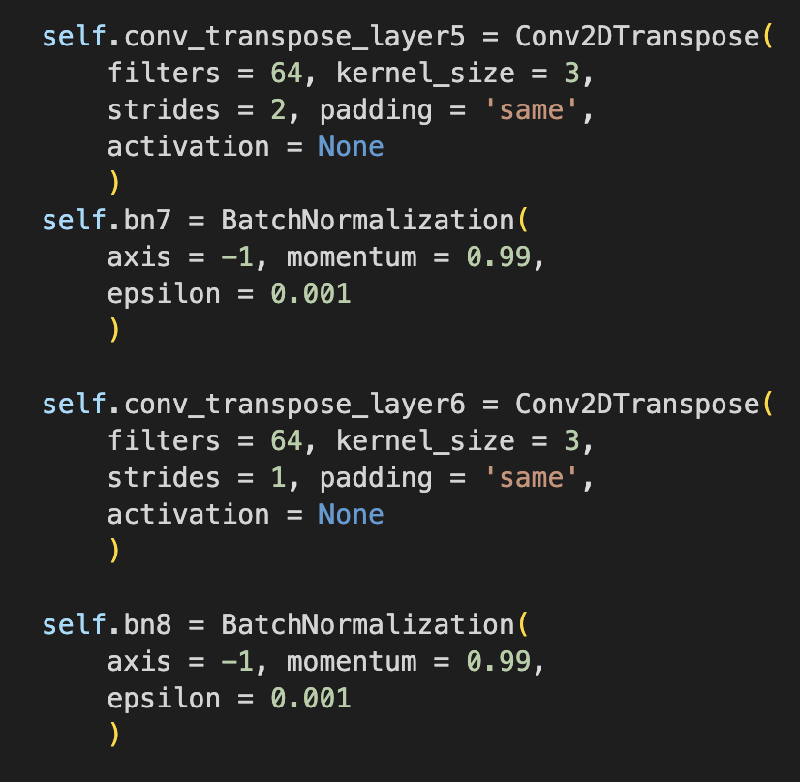

The decoder concludes its operation with a final convolutional transpose layer:

* **Final Convolutional Transpose Layer (final_conv_layer)**: This layer adjusts the number of output channels to match that of the original images (e.g., 3 channels for RGB images). It acts as the final step in reconstructing the image from the encoded data, ensuring that the output matches the size and shape of the input images.

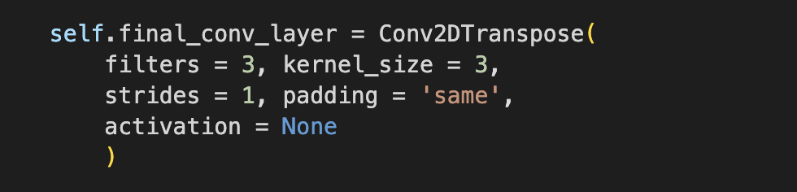

The outcome of this intricate process is a reconstructed image that closely resembles the original input, albeit with some potential loss in detail inherent to the encoding-decoding process. The **Conv6_Decoder** transforms the abstract, compressed information back into a tangible, visual form, showcasing the remarkable ability of Convolutional VAEs to generate and refine images based on encoded representations.

Through this detailed mechanism, the **Conv6_Decoder** plays a crucial role in the VAE architecture, enabling the model not just to compress and encode images, but also to regenerate them, paving the way for applications in image generation, enhancement, and more.

**Working of VAE Model:**

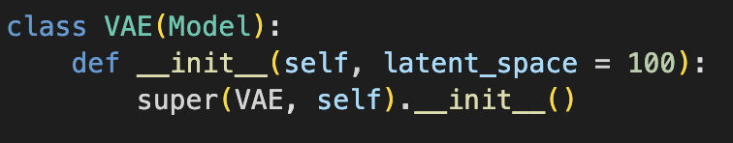

The **VAE** class represents a Variational Autoencoder (VAE), a type of neural network designed for generating and modeling complex data distributions, such as images. This class integrates custom encoder (**Conv6_Encoder**) and decoder (**Conv6_Decoder**) components to work with image data. Let's break down its functionality into simpler terms:

**Overview**

A VAE works in two main phases:

1. **Encoding**: It compresses the input data (e.g., images) into a compact representation known as the latent space.
2. **Decoding**: It reconstructs the input data from the latent space representation, aiming to match the original input as closely as possible.

**Components of the VAE Class:**

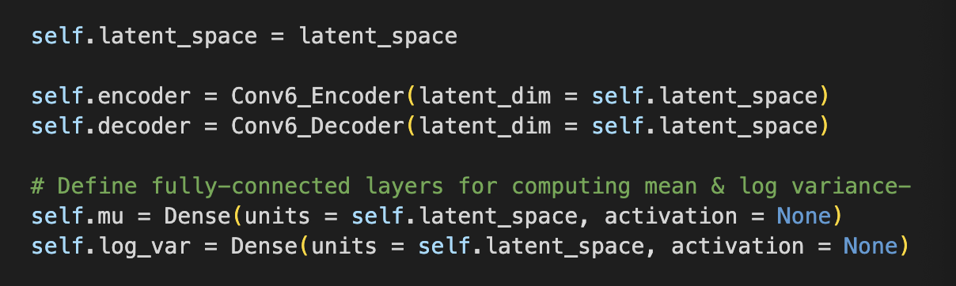

* **Latent Space**: Think of the latent space as a compressed storage room where essential information about each image is kept in a much smaller, compact form. The **latent_space** attribute defines the size of this room, determining how much information it can hold.
* **Encoder**: The **Conv6_Encoder** acts like a smart camera, capturing the essence of an image and storing it in the latent space. It focuses on what's important, discarding unnecessary details to compress the image efficiently.
* **Decoder**: The **Conv6_Decoder** works like a skilled artist who takes the compact representation from the latent space and uses it to recreate the original image. It aims to fill in the details, colors, and textures to produce an image that closely resembles the original.
* **Mean (μ) and Log Variance (log σ²)**: The encoder not only compresses the image but also provides a "map" (mean) and "flexibility" (log variance) for recreating the image. These two components help the decoder understand where to look in the latent space and how much variation to consider during reconstruction.

**Reparameterization Trick:**

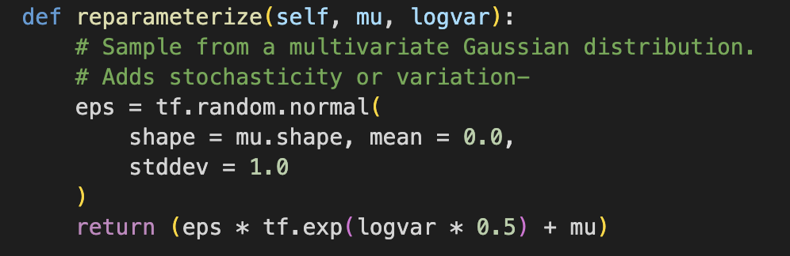

* The **reparametrize** method is a clever trick that allows the VAE to randomly sample from the latent space while still being able to learn through gradient descent. It introduces randomness by adding a bit of noise (ε) to the process, which helps the VAE generate new images that are similar but not identical to the ones it has seen before.

**Generating New Images**

* When the VAE processes an image, the encoder compresses it into the latent space, and then the decoder attempts to reconstruct it. However, the latent space representation slightly (using the reparameterization trick), the VAE can also generate new images that share characteristics with the original dataset but are uniquely different.

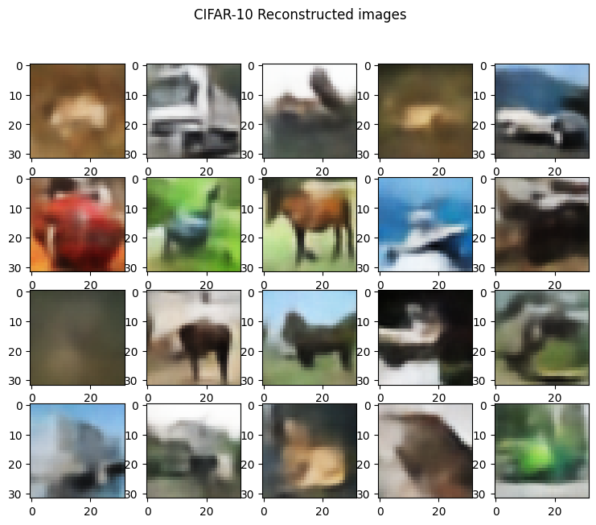

**Final Output**

* The final output of the **VAE** class during the reconstruction process includes not just the reconstructed image but also the mean and log variance used for the latent space representation. This information is crucial for understanding how the VAE interprets and reconstructs images, as well as for generating new images.

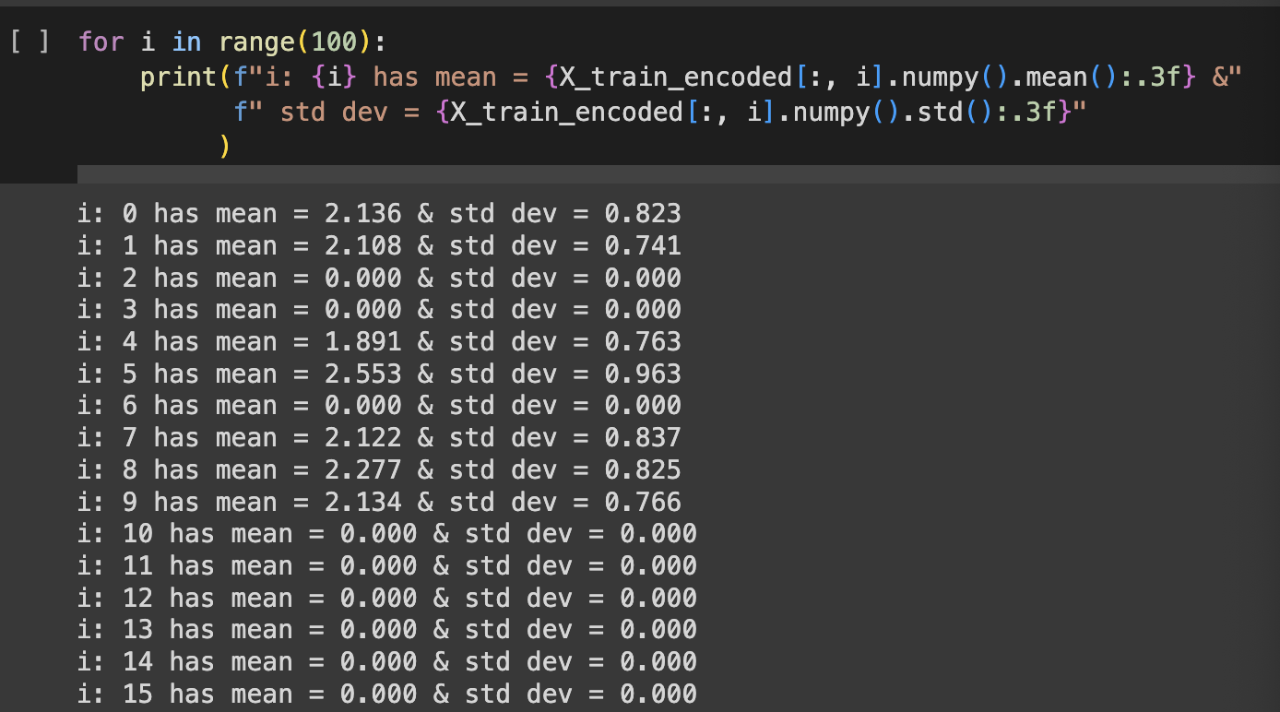

**Purpose of the model Method:**

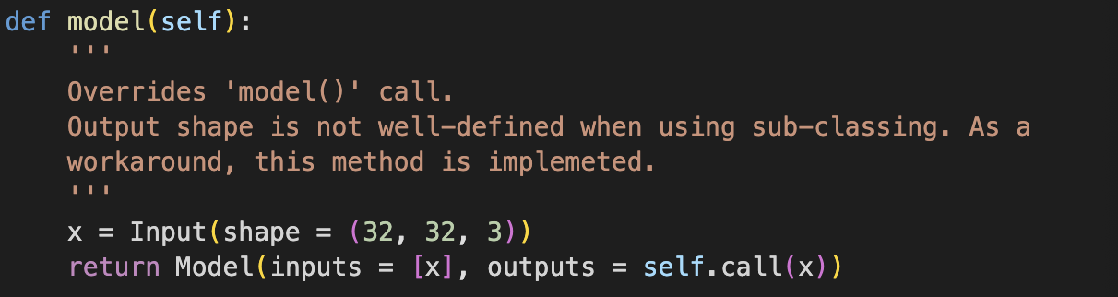

* The **model** method is a special addition that helps define the overall structure of the VAE when using model subclassing in TensorFlow. It specifies the input and output layers, making it easier to visualize and work with the model in certain high-level APIs.

In simple terms, this VAE is like a complex machine that can both remember and recreate images, as well as dream up new ones, by understanding and manipulating the essence of the visual information it's trained on.

**Results:**

* Total Training loss for 300 epochs

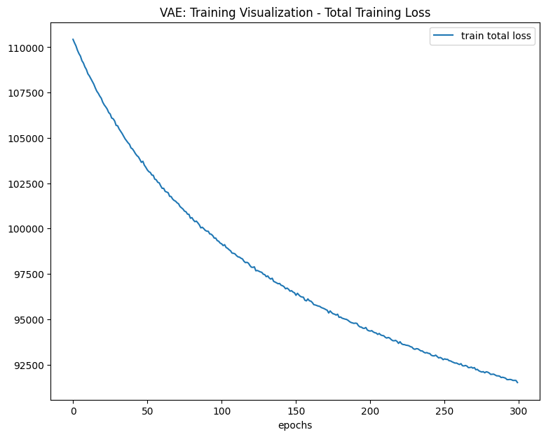

* Total Validation loss for 300 epochs.

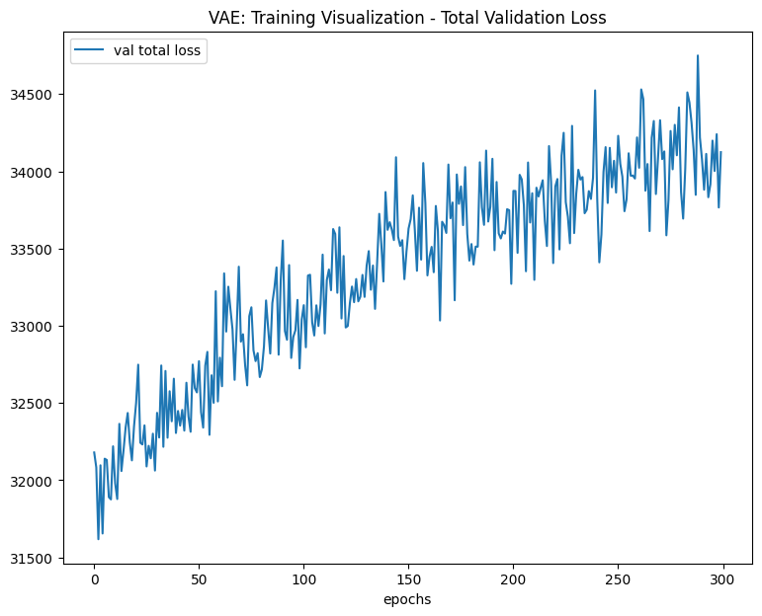

* Total Training loss for Reconstructed image for 300 epochs

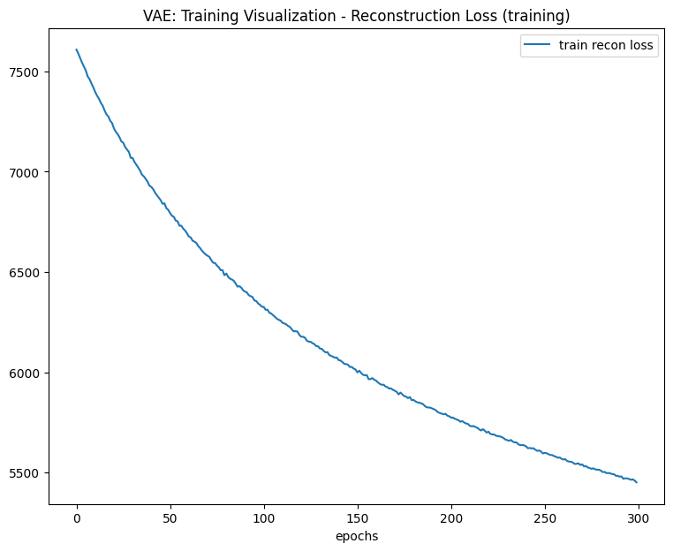

* Total Validation loss for Reconstructed images for 300 epochs

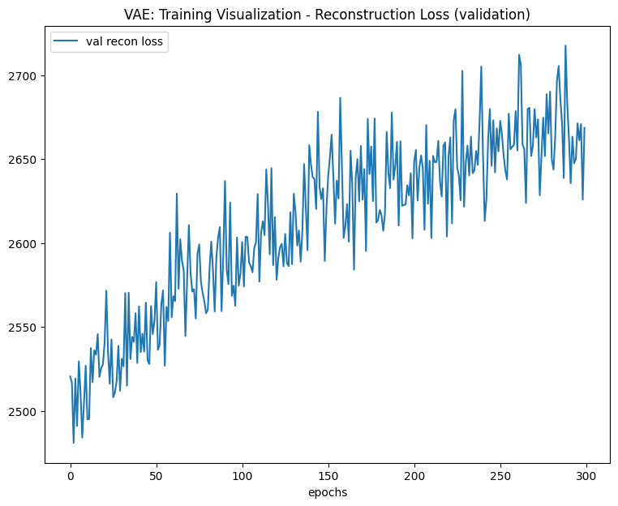

* Sample image of CIFAR-10 Dataset

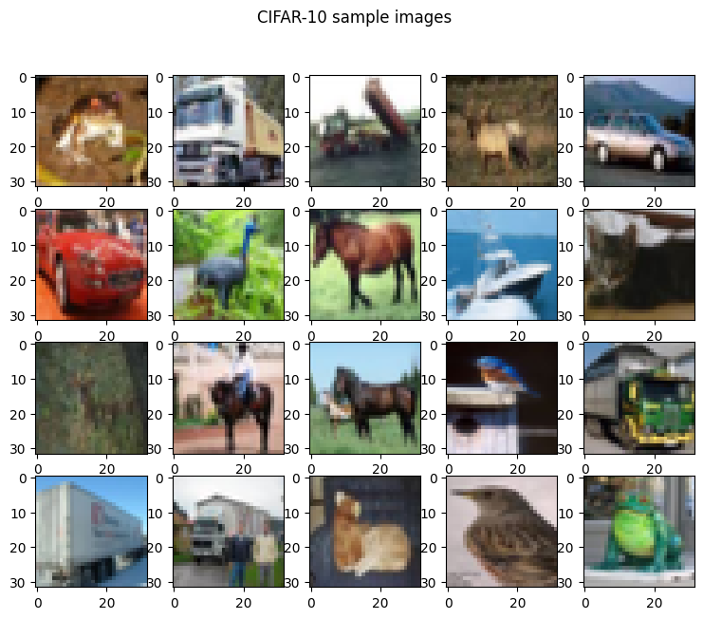

* Reconstructed image for 100 epochs.

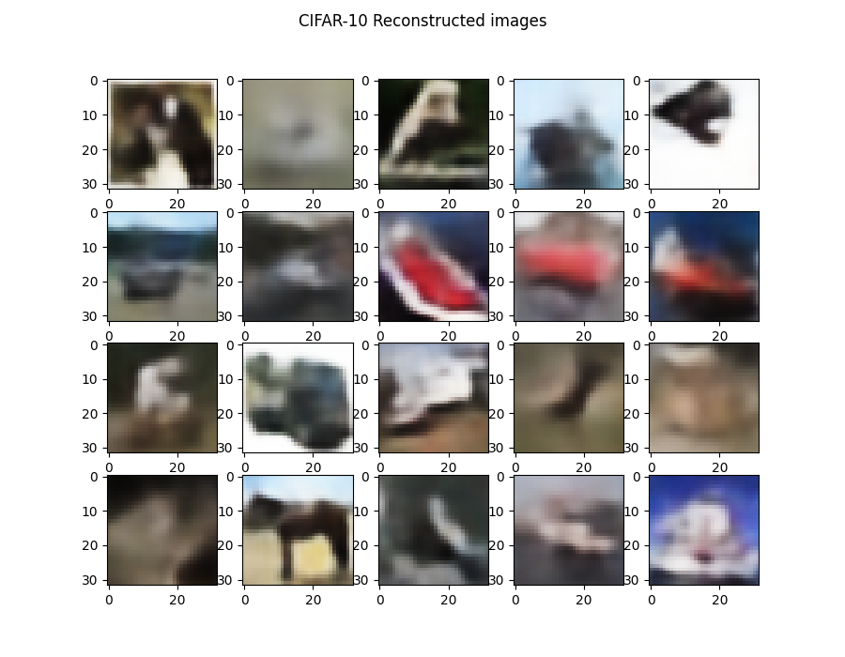

* Reconstructed image for 100epochs

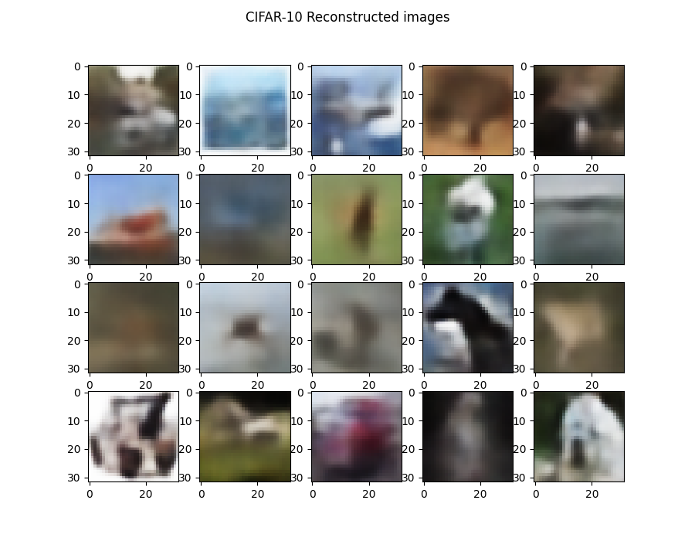

* Reconstructed Image for 300 epochs



* Random Training image

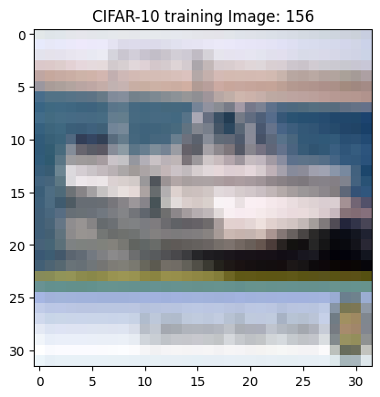

* Random Reconstructed image

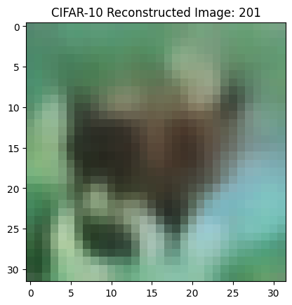

* 3D Latent Representation using Scatter plot:

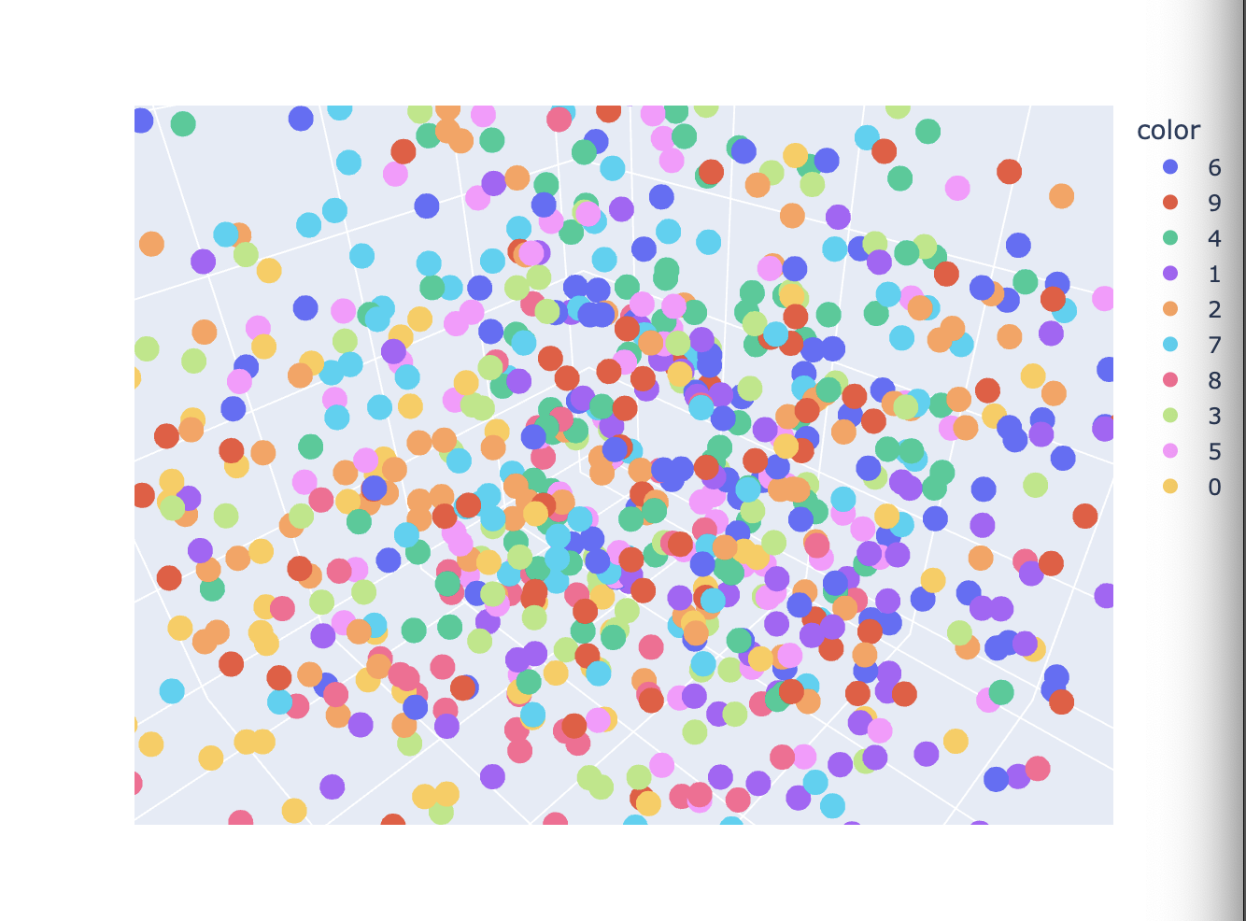

**Can We Use Normal VAE Instead of Convolutional VAE?**

Yes, we can use a normal VAE instead of a Convolutional VAE, but the choice should be based on the type of data you're working with and the specific requirements of your task. For image data, a Convolutional VAE is usually preferred due to its efficiency in handling the spatial structure of images and its ability to learn more meaningful features through convolutional layers.Top of Form

Bottom of Form

1. **Generative Adversarial Networks (GANs)**
   1. **Generative Adversarial Network using MNIST Dataset:**

**Dataset importing:**



**Generator Model:** Itstarts not very good at drawing numbers. It takes random noise (imagine scribbles) and tries to make images of numbers from it. Its goal is to fool the discriminator into thinking the fake numbers are real.

* **build_generator(z_dim):** This function builds the generator model, which takes a random noise vector as input and generates images like those in the MNIST dataset. The model upscales the input noise through dense layers with Leaky ReLU activation and Batch Normalization for stabilization, ending with a tanh-activated layer reshaped into the image dimensions.

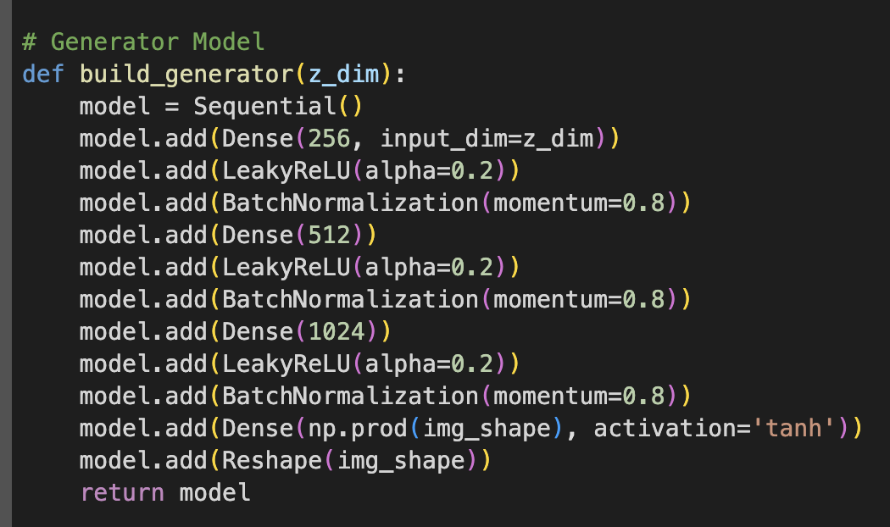

**Discriminator Model:** It's like a teacher who checks if the drawing is a real number from the dataset or a fake one made up by the generator. It gets better over time at spotting fakes.

* **build_discriminator(img_shape):** This function builds the discriminator model, which is a simple neural network designed to classify images as real (from the MNIST dataset) or fake (generated by the generator). The model uses LeakyReLU activation for non-linearity and a final layer with sigmoid activation to output a probability indicating whether the input image is real or fake.

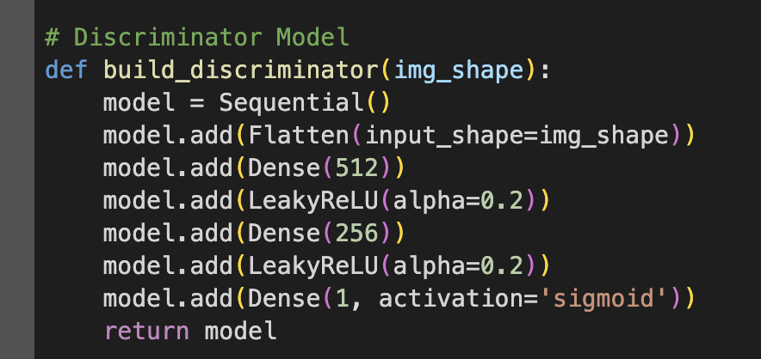

**Saving Generated Images:** Periodically, the code saves some of the generator's drawings so you can see how well it's doing at creating images that look like real handwritten numbers.

* **save_imgs(generator, epoch, n_examples=10, dim=(1, 10), figsize=(10, 1)):** A utility function to save generated images at given epochs during training. It generates n_examples of images using the generator, scales the pixel values to [0,1] for visualization, and saves the images as a PNG file.

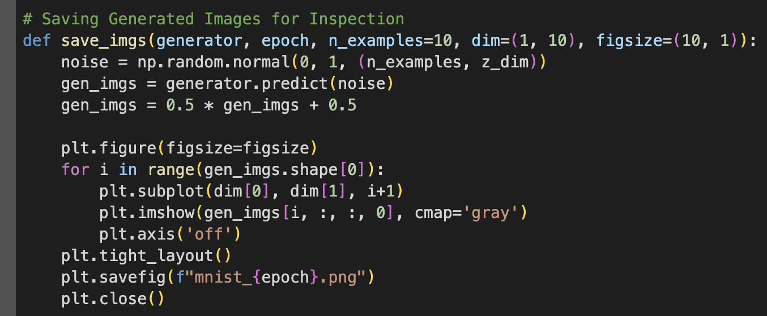

**Training the GAN:** The generator and discriminator are trained together in a game of cat and mouse. The discriminator learns to get better at telling real from fake, and the generator tries to get so good at making images that the discriminator thinks they're real. Over time, the generator's drawings start to look more and more like real handwritten numbers.

* **train(generator, discriminator, combined, epochs,batch_size=128,save_interval=50)**: This function orchestrates the training process of the GAN, including both the discriminator and generator models. The training involves alternating between training the discriminator on real and fake images and training the generator to produce images that the discriminator classifies as real. The function also handles data preparation, batch creation, and periodically saving generated images for inspection.

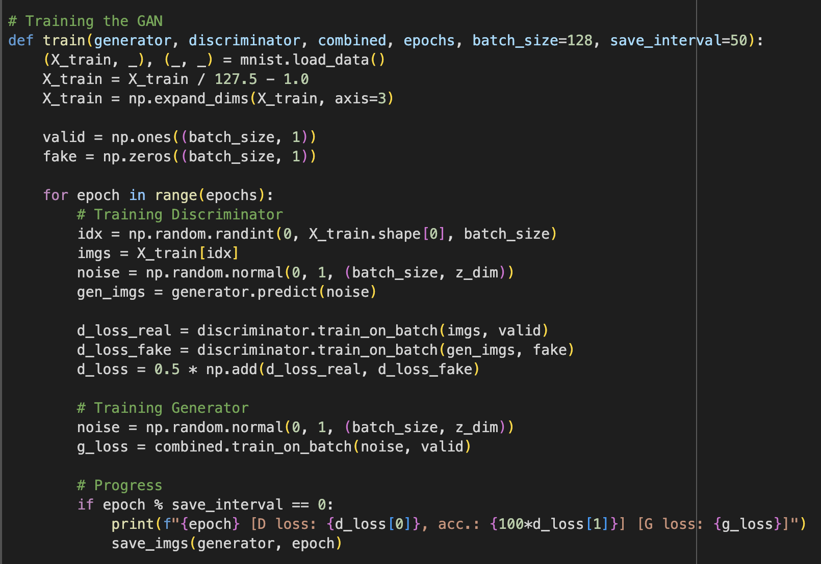

**Model Configuration and Training Execution**

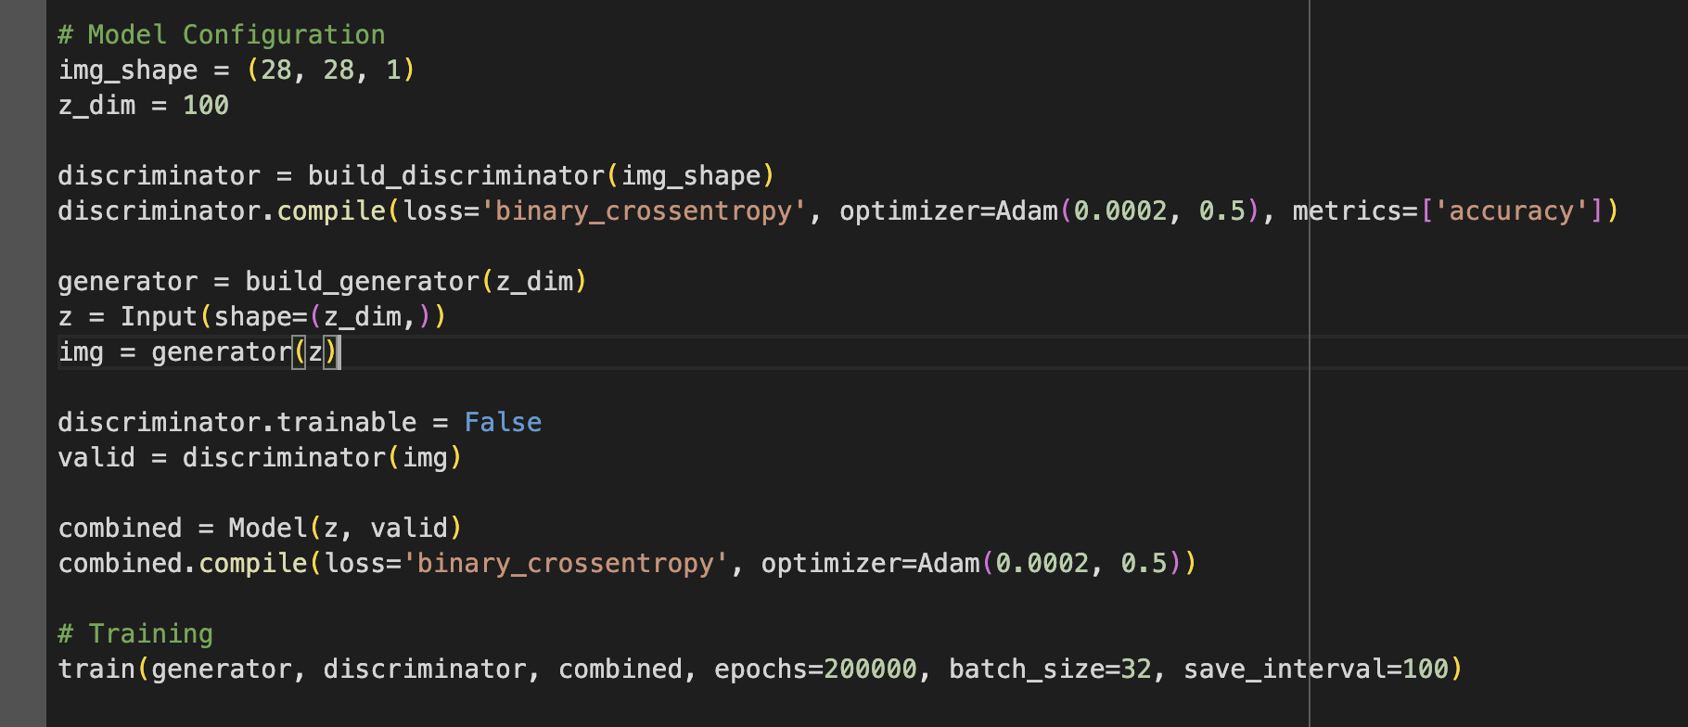

* Here, the discriminator and generator models are instantiated, compiled with the **Adam** optimizer, and a **binary_crossentropy** loss function. The discriminator's accuracy metric is also tracked.
* A combined model is created by setting the discriminator's **trainable** attribute to **False** and then connecting the generator and discriminator. This combined model is used to update the generator's weights, aiming to fool the discriminator into classifying the generated images as real.
* The training is executed with specified **epochs**, **batch_size**, and an interval for saving generated images for inspection.

**How it Works in Steps**:

1. **Setup**: It prepares both the discriminator and generator, giving them the tools they need to learn (this includes setting up the rules for their training).
2. **Learning**: The discriminator looks at both real numbers from the dataset and fake ones from the generator. It tries to learn the difference. Meanwhile, the generator keeps improving its drawings, trying to make them indistinguishable from real ones.
3. **Checking Progress**: Every so often, the code checks how well the generator is doing by saving its current drawings. This lets you see how much it improves over time.

**Generated samples with different epochs:**

* **At 0th Epoch:**

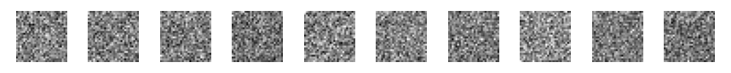

* At 1000th Epoch:

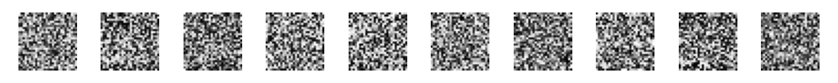

* At 10000 Epoch:

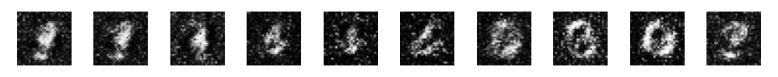

* At 81900th Epoch:

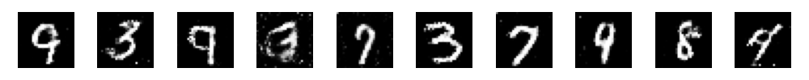

* At 100000th Epoch:

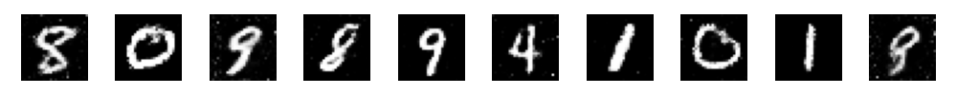

* At 1196000th Epoch:

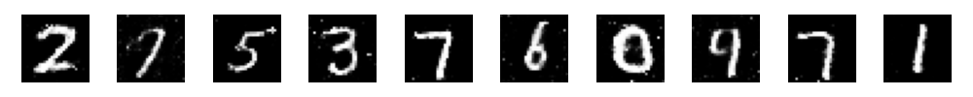

**Visualization for Generator and Discriminator Losses:**

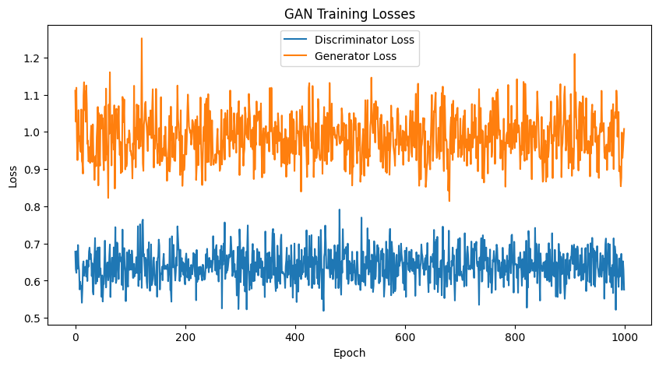

**Probability Comparison of real or fake data:**

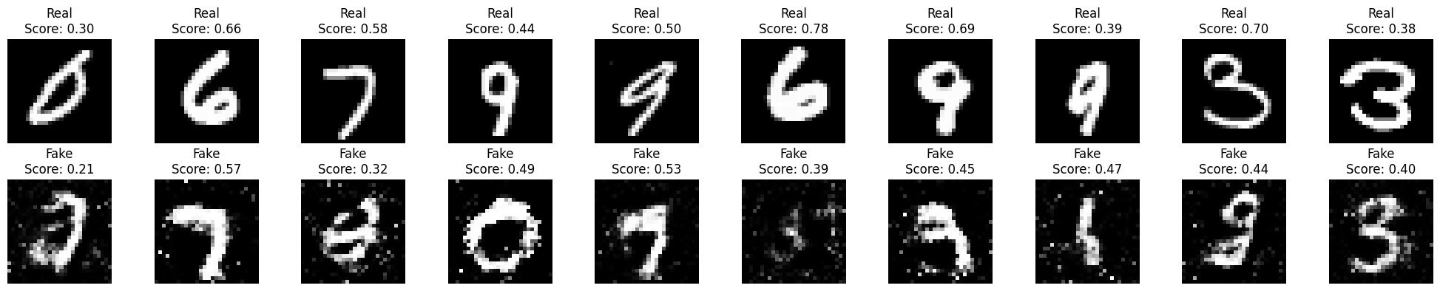

**Plotting statistics of real and fake data with respective mean and standard deviation:**

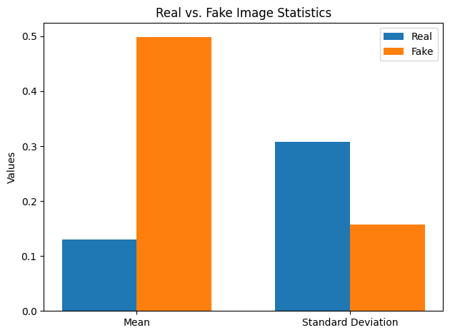

* 1. **Generative Adversarial Network using CIFAR-10 Dataset:**

**Dataset downloading:**

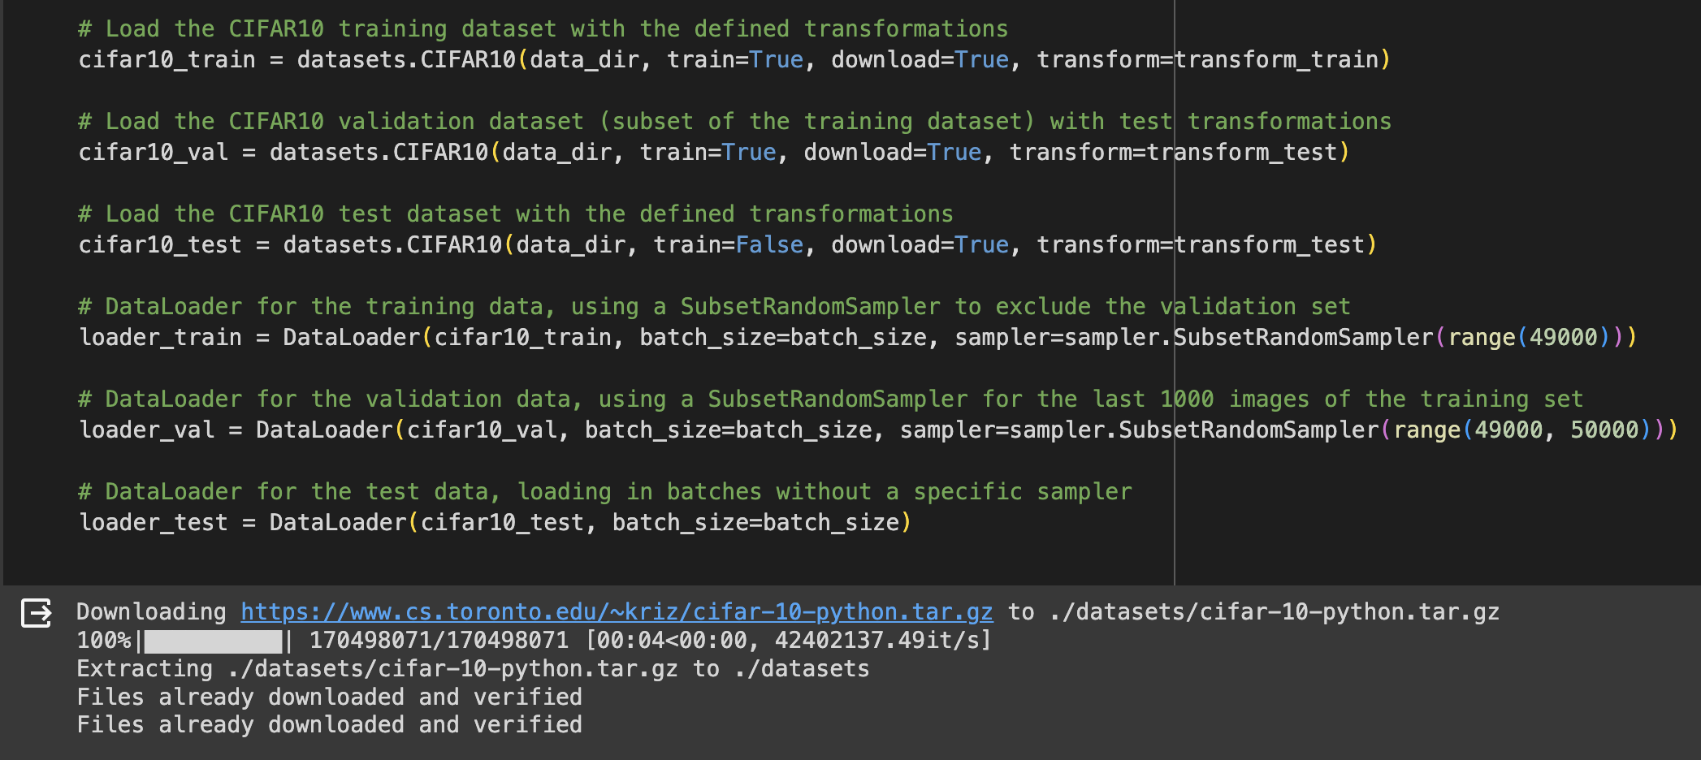

**Generator**

The Generator class is designed to generate new data instances that resemble the training data. It takes a latent vector (a fixed-length random vector) as input and outputs data that mimics the real data distribution. The architecture uses transposed convolutions (also known as deconvolutions) to up sample the latent vector into a data instance of the desired size.

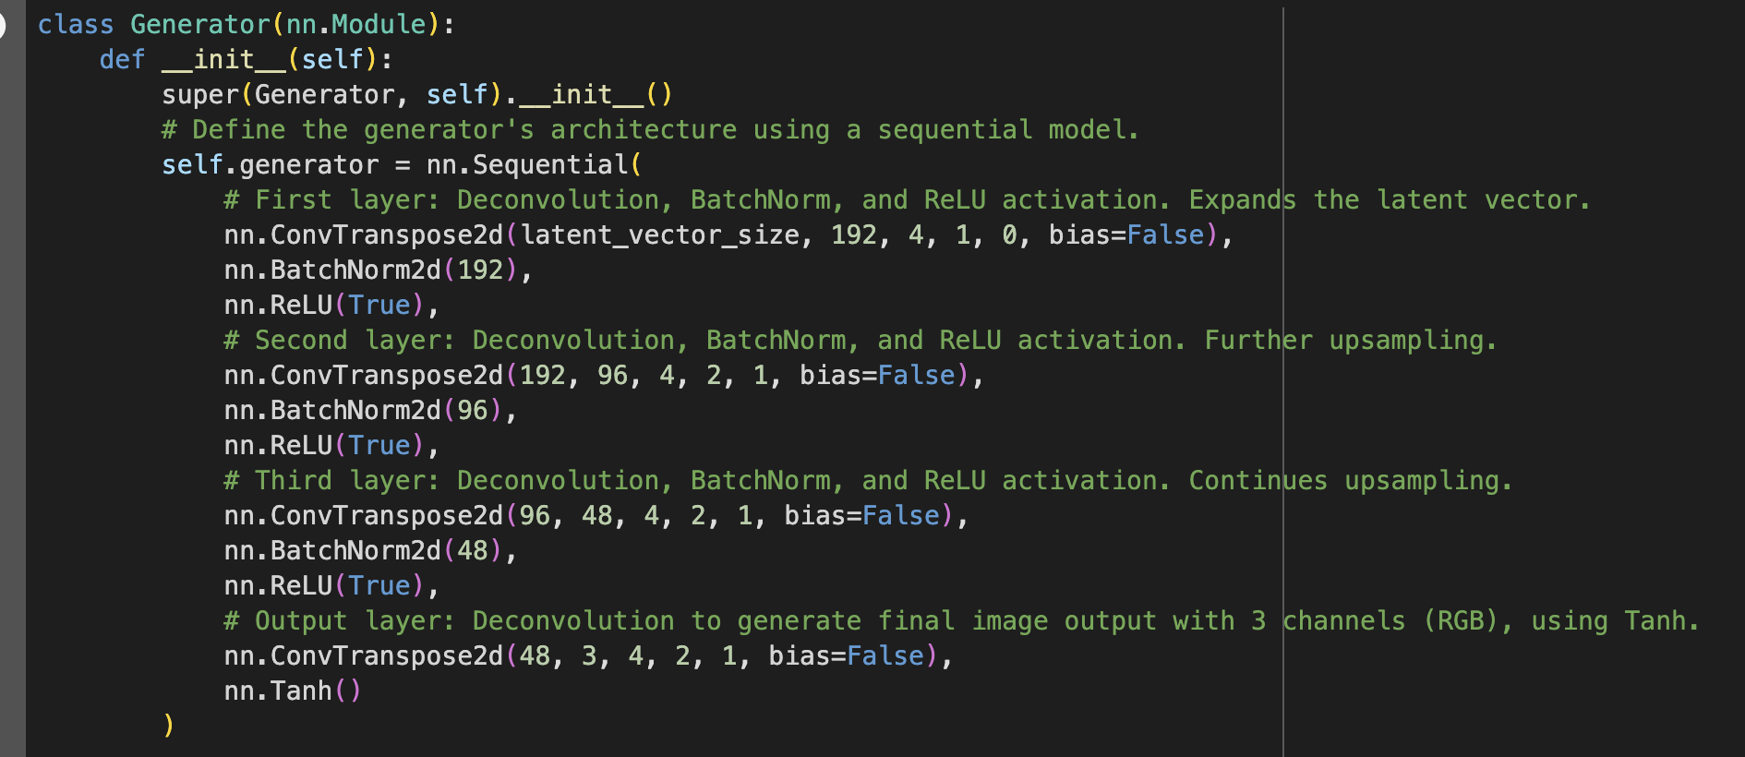

* **First Layer**: Expands the latent vector using a transposed convolution, followed by batch normalization and ReLU activation. This is the beginning of the process of upsampling and shaping the input into a form closer to the final output.
* **Second and Third Layers**: Continue the process of upsampling and feature learning through additional transposed convolution layers, each followed by batch normalization and ReLU activation. These layers progressively increase the spatial dimensions of the feature maps.
* **Output Layer**: Uses a transposed convolution to adjust the number of output channels to 3 (for RGB images), with the Tanh activation function to scale the output pixel values to the range [-1, 1], which is a common practice for GANs.

**Generator's forward:** Takes a latent vector as input and passes it through the generator network to produce a synthetic image.

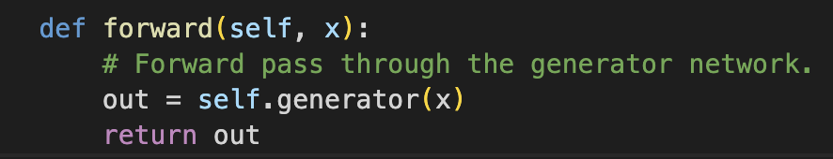

**Discriminator**

The Discriminator class is designed to distinguish between instances of real data from the training set and fake data generated by the Generator. It takes an image as input and outputs a single scalar representing the probability that the input image is real (as opposed to fake).

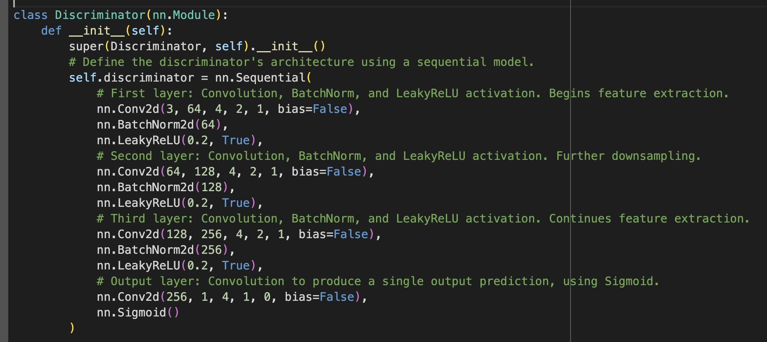

* First Layer: Begins the feature extraction process with a convolution, followed by batch normalization and LeakyReLU activation. This layer starts the process of downsampling the input image.
* Second and Third Layers: Further extract and compress features through additional convolution layers, each followed by batch normalization and LeakyReLU activation. These layers continue the process of downsampling and increasing the depth of the feature maps.
* Output Layer: A final convolution layer reduces the feature map to a single scalar value. The Sigmoid activation function then scales this value to the range [0, 1], representing the probability that the input image is real.

**Discriminator's forward:** Takes an image (either real or generated) as input and passes it through the discriminator network, outputting a probability that the image is real.



Together, these two models are trained in tandem in a GAN setup: the Generator tries to produce increasingly realistic images, while the Discriminator becomes better at distinguishing real images from generated ones. This adversarial training process continues until the Generator produces images that are indistinguishable from real images, at which point the Discriminator outputs a probability close to 0.5 for both real and generated images, indicating an inability to distinguish between the two.

**Variables Initialization:**

* train_losses_generator and train_losses_discriminator lists are initialized to track the average losses of the Generator and Discriminator across epochs.
* epoch_loss_discriminator and epoch_loss_generator accumulate the losses for the Discriminator and Generator, respectively, within each epoch.

**Training Loop:**

* The outer loop iterates over each epoch, while the inner loop iterates over each batch of data from loader_train.
* For each batch:
  + **Discriminator Training on Real Data**:

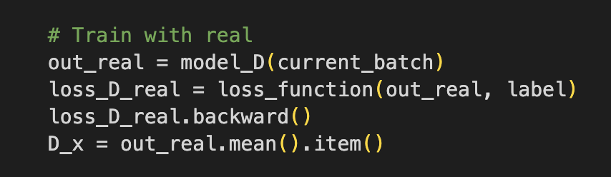

* + - The Discriminator's gradients are zeroed out to ensure that the update is only based on the current batch.
    - Real images (current_batch) are passed through the Discriminator to get predictions (out_real).
    - A loss (loss_D_real) is calculated using these predictions and a target label indicating that these images are real. A label smoothing technique is applied by using real_label*0.9 instead of a hard 1.0 to prevent the Discriminator from becoming too confident.
    - The gradients are computed with. backward () on the real loss, and the Discriminator's optimizer (optimizerD) is updated.
  + Discriminator Training on Fake Data:

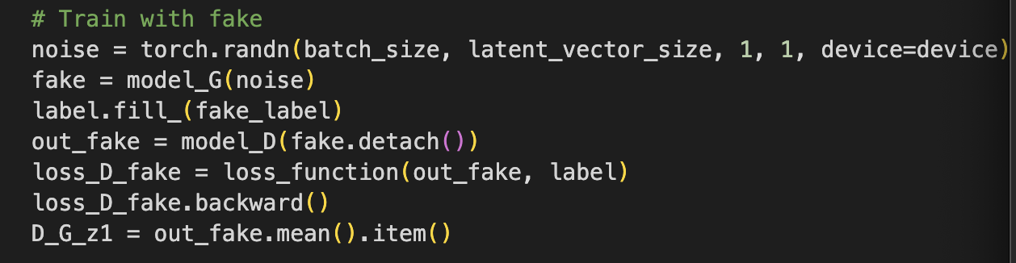

* + - Fake images are generated by passing noise through the Generator.
    - These fake images are passed through the Discriminator to get predictions (out_fake), and a loss (loss_D_fake) is calculated using these predictions and a target label indicating that these images are fake.
    - The gradients are computed and added to those of the real data loss, then the Discriminator's optimizer is updated again.
  + **Generator Training**:

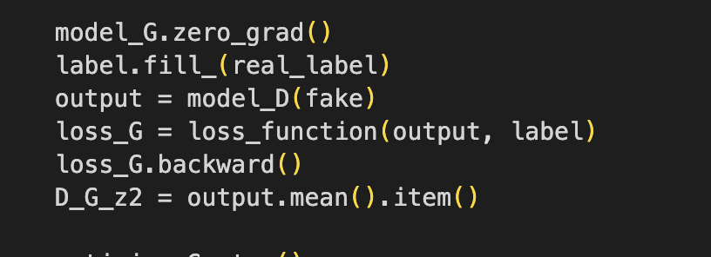

* + - The Generator's gradients are zeroed out.
    - Fake images, already generated for the Discriminator training, are used again. This time, the label is flipped to indicate these images are "real" to fool the Discriminator.
    - The Discriminator's predictions on these fake images are used to compute the Generator's loss (loss_G), trying to minimize the distance between the Discriminator's predictions and the "real" label.
    - The Generator's loss is used to compute gradients, and its optimizer (optimizerG) is updated.
  + **Loss Logging and Image Saving:**

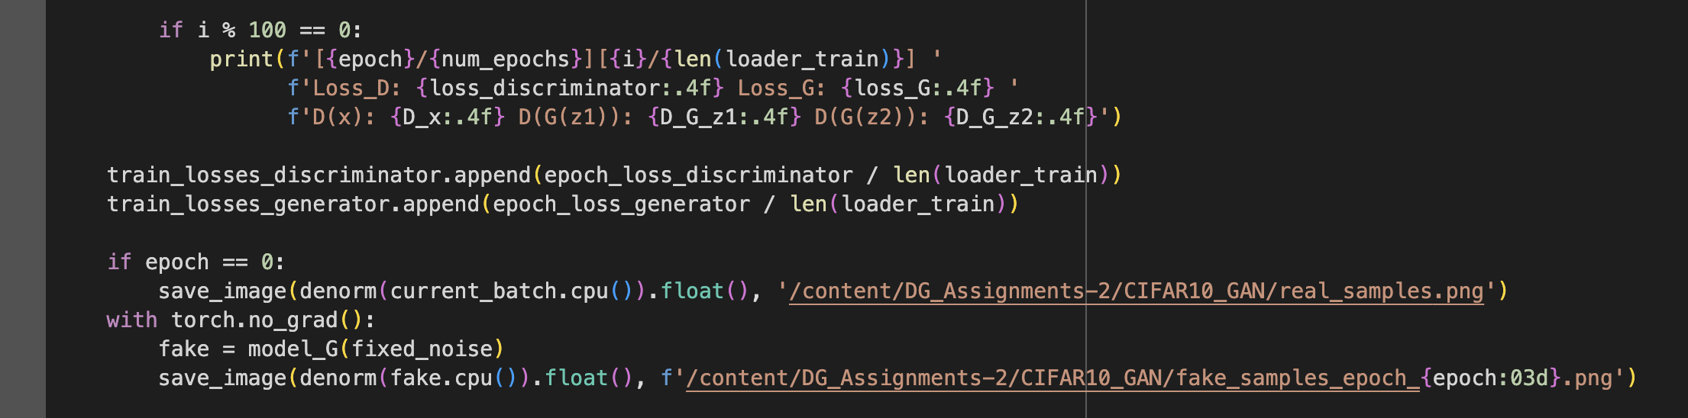

* Every 100 batches, the training losses and the Discriminator's predictions on real and fake data are printed out to monitor the training progress.
* At the end of each epoch, the average losses for the Discriminator and Generator are recorded.
* Real images from the first batch of the first epoch and fake images generated from a fixed noise vector (fixed_noise) at the end of each epoch are saved. This helps visualize the Generator's progress over time.
  + **Model Saving:**



* At the end of the training, both the Discriminator and Generator models are saved using PyTorch's JIT compilation.

**Results:**

* + **Sample image from Data Loader:**

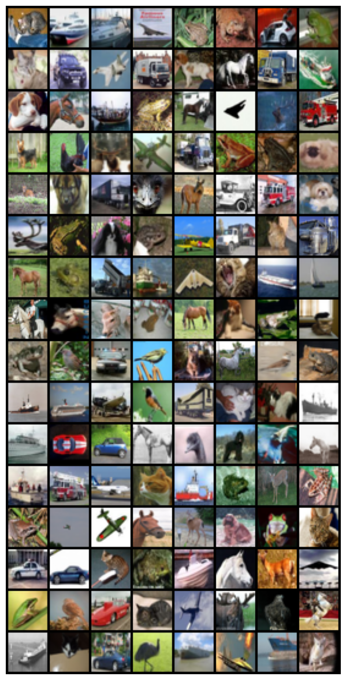

* + - **Generated image after training for 100 epochs:**

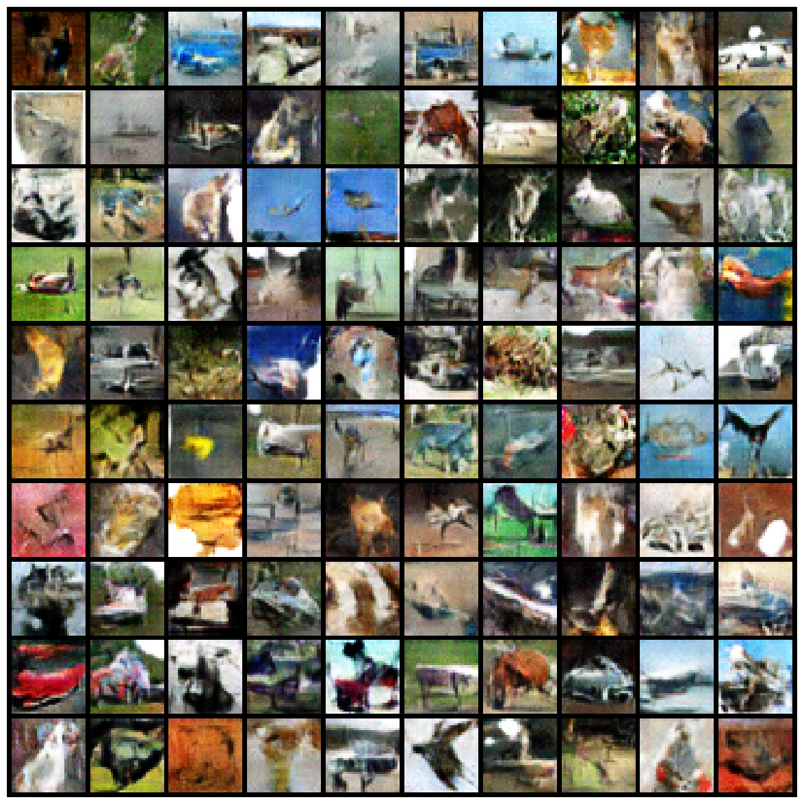

* + - * Generated image at 0th epoch:

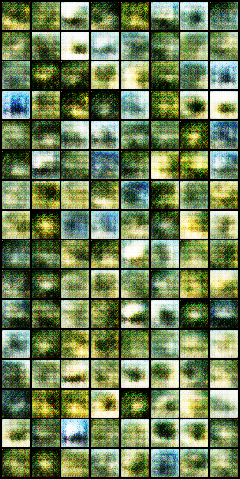

* + - **Generated image at 60th epoch:**

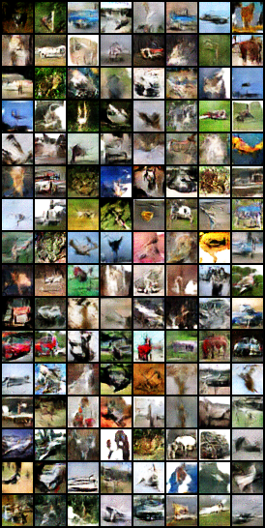

* + - **Generated image at 90th epoch:**

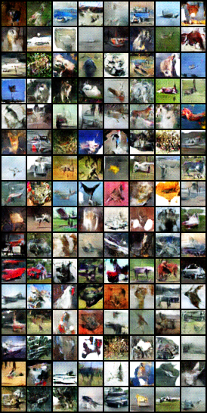

* + - **Real image:**

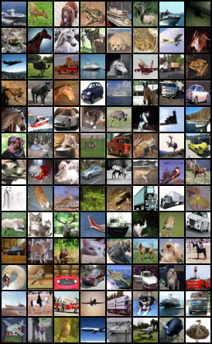

**Comparative analysis of the implemented models**:

**Comparing based on Execution Time:** Testing the model with 10epochs using Tesla T4 GPU.

* **VAE & GAN Using (MNIST vs. CIFAR-10):**
  + VAE MNIST took 2.15 minutes to complete the training process.
  + GAN MNIST took 6 seconds to complete the training process.
  + VAE CIFAR-10 took 5.8 minutes to complete the training process.
  + GAN CIFAR-10 took 7.23 minutes to complete the training process.
* When I used a powerful Tesla T4 GPU to train two different types of Generative models, one called VAE and the other called GAN, how to create pictures like those in two famous sets of images (MNIST and CIFAR-10), this is what I observed while training both the models with both datasets:
* The VAE Model, when learning from the MNIST Dataset, finished its training process in just about 2 minutes and 9 seconds.
* The GAN Model, while training at the MNIST digits, was super quick and done in only 6 seconds!
* When we tried CIFAR-10, which is more like advanced pictures with images of trucks, birds, and other stuff, the VAE model took a bit longer to learn, about 5 minutes and 48 seconds.
* The GAN Model also took more time with CIFAR-10, finishing up in 7 minutes and almost 14 seconds.

So, in simple terms, both datasets learned faster with the simpler set of digit images than with the more complex and colorful images of various objects.

* **Comparing based on Plotting loss curves:** Plotting the model with loss curves for 10epochs.
  + VAE MNIST plotting for the training process.



* The graph shows three lines indicating the total loss, reconstruction loss (RL), and a term involving the KL divergence (β*KLD).
* The total loss (RL+β*KLD) and the reconstruction loss both decrease sharply initially and then more gradually, which suggests that the model quickly learned to reconstruct the digits and then refined its understanding over time.
* The β*KLD term is lower and decreases steadily, indicating that the model is effectively balancing the reconstruction with the regularizing effect of the KL divergence.
  + GAN MNIST plotting for the training process.

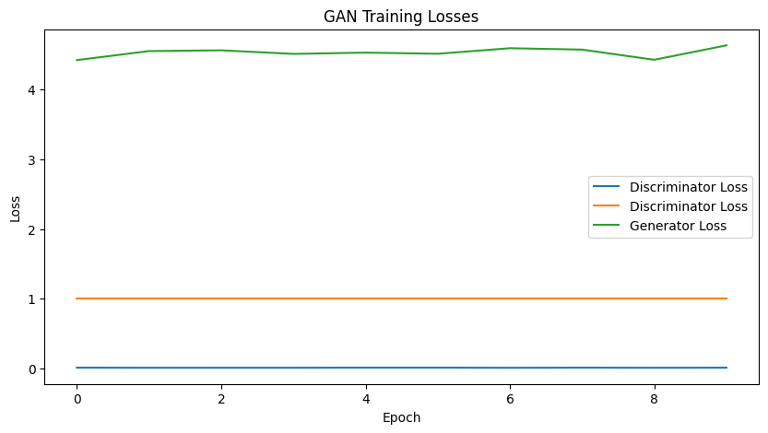

* The GAN losses for CIFAR-10 show the discriminator's loss is much higher compared to the GAN trained on MNIST, fluctuating as it learns.
* The generator loss also starts higher than in the MNIST case but decreases over time, suggesting the generator improves but has a harder challenge to overcome due to CIFAR-10's complexity.
  + VAE CIFAR-10 plotting for the training process.

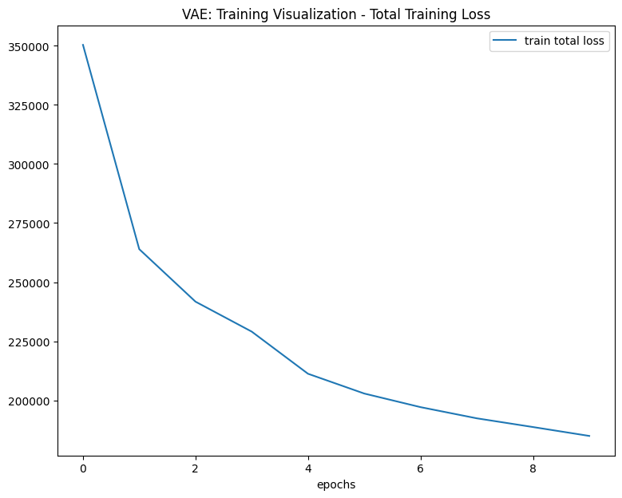

* A single line indicates the total training loss for the VAE. It shows a steep decline initially, like the VAE on MNIST, but the loss values are much higher overall. This indicates that reconstructing CIFAR-10 images is a more difficult task for the VAE, as expected due to the dataset's complexity.
  + GAN CIFAR-10 plotting for the training process.

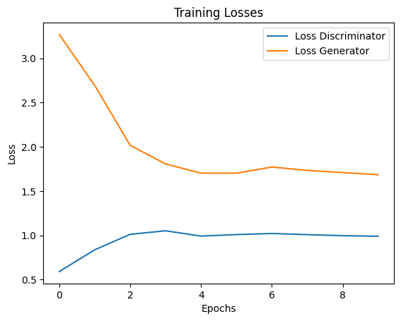

* The GAN graph shows the losses for the discriminator and the generator.
* The discriminator loss remains relatively stable and low, suggesting that it quickly became good at distinguishing real images from fake ones.
* The generator loss decreases, which indicates that over time, the generator is getting better at fooling the discriminator.
* In summary, both VAEs and GANs have an easier time training with MNIST, resulting in lower loss values and more stable learning curves. CIFAR-10, with its more complex and colorful images, presents a greater challenge, reflected in the higher and more variable loss values for both models. The training process for CIFAR-10 is more difficult and less stable, indicating that these models must work harder to understand and generate the more varied and detailed images in the CIFAR-10 dataset.

**Comparing based on Generated Images:**

Let’s look at what these images tell us about how the VAE and GAN models perform when they're learning to create new images after seeing MNIST and CIFAR-10 datasets for 10 epochs.

* + VAE MNIST

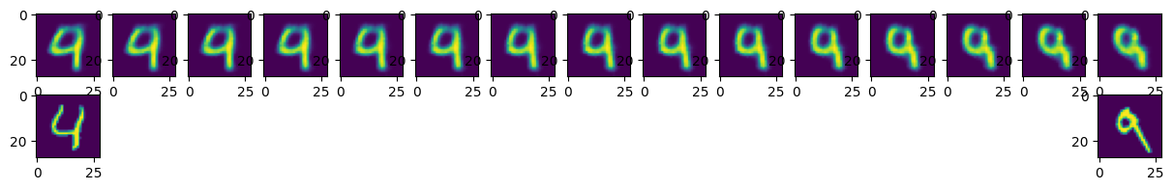

* + GAN MNIST

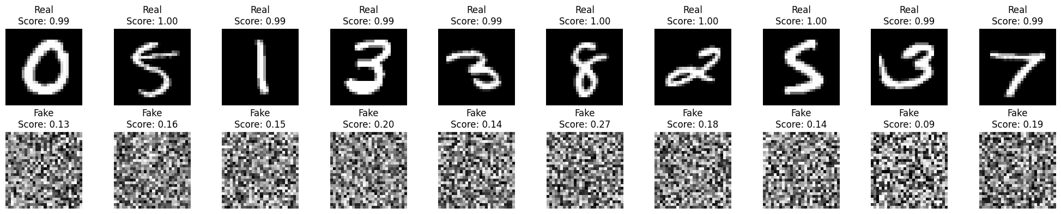

* + VAE CIFAR-10

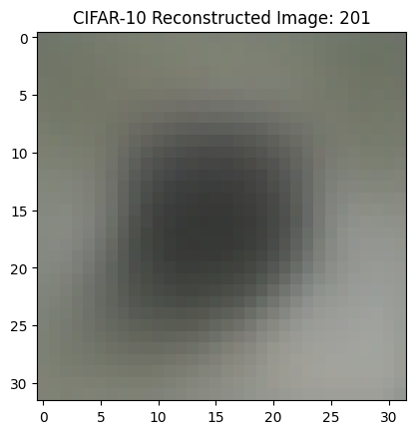

* + GAN CIFAR-10

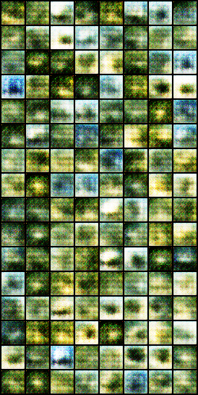

**For the VAE model:**

* On the **MNIST dataset**, which is just simple hand-written digits, the VAE seems to do a pretty good job. The new images it creates look quite a bit like the originals, although they might be a little blurry around the edges.
* When the VAE turns its attention to the **CIFAR-10 dataset**, which has more complex images like animals and vehicles, it has a harder time. The images it generates are much blurrier and it's not always easy to make out what they're supposed to be.

**For the GAN model:**

* With the **MNIST dataset**, the GAN is unclear with blurry. It generates new digit images that are crisp and clear, and sometimes you might not even be able to tell they're not real.
* For the **CIFAR-10 dataset**, it's a tougher challenge for the GAN, but it still does a reasonable job. The generated images are recognizable, but they don't have the same sharpness and detail as the simpler digit images.

**Challenges faced and Discussions for doing this assignment:**

1. The computational time of the model took overnight, and I can even say more than 9.5 hours for some code, even though I got completely blurry generated images for VAE-CIFAR10.
2. I forgot to save loss values and later I realized after training a model that I needed loss values for plotting.
3. I purchased Google Collab Pro two times; I completely ran out of my Collab RAM for 1st time.
4. For GAN, CIFAR-10 training process I kept 200000 epochs, and for 128000 epochs I ran out of my ram to train those many epochs took me 7.45hours, so I couldn’t save my loss values and plotting for those many epochs.
5. I almost worked for this assignment, to keep on track for my training process.
6. Purchasing the Google Collab pro, cost me 20$(for 2 times).
7. Finding the correct hyperparameters for the model, took me a lot of time.
8. For VAE-MNIST, my complete execution part is done, later I realized I needed to add the latent representation code part to my previous code.
9. I started my assignment on 12th February, still, it took me a lot of time to fix bugs and understand the working process of GAN and VAE.
10. The loss functions used in VAEs and GANs are not always helpful, it gave me an unexpected behavior during the training process.
11. Training with more epochs caused me to overfit the model.
12. Looking at the quality of the generated images, we see that GANs tend to create sharper images compared to VAEs, which means they might be better for projects where picture clarity is super important.
13. For the simpler MNIST numbers, the VAE was quick at learning, taking just over 2 minutes, while the GAN was lightning fast, taking only 6 seconds! The pictures they made were quite good; the numbers were easy to recognize and looked very similar to the real ones.
14. With the trickier CIFAR-10 images, the VAE took a bit longer, about 6 minutes, and the GAN took the longest, over 7 minutes. The images they created were a bit fuzzier and not as clear as the real ones, especially for the VAE. This tells us that it's tougher for the neural networks to learn from more complex pictures.
15. The loss curves from our training give us clues about how the neural networks improved over time. A smoother curve means the network is getting better in a steady way.
16. or the VAE, we watched two types of loss: one for how well the picture was recreated and another for how well the network learned the data's diversity.
17. For the GANs, we kept an eye on two losses as well: one for the part of the network that creates images and another for the part that judges them.